|  |  |  |  |
| --- | --- | --- | --- |
| logo ngan.png | | **MINISTRY OF EDUCATION AND TRAINING** | |
| **FPT UNIVERSITY** | |
| **CAPSTONE PROJECT DOCUMENT** | |
| **BUILDING A WEBSITE SUPPORT THE ACTIVITIES “TIẾP SỨC MÙA THI” CAMPAIGN** | |
|  | |
| |  |  | | --- | --- | | **Group 22** | | | **Group Members** | |  |  | | --- | --- | | SE60769 | Nguyen Duy Khoa | | SE60687 | Le Nguyen Huu Tri | | 60358 | Nguyen Dinh Tuan | | 60325 | Tran Nguyen Kim Vinh | | 60339 | Nguyen Vinh Hien | | | **Supervisor** | Nguyen Trong Tai | | **Ext Supervisor** | N/A | | **Capstone Project Code** | TSMT | | |
| - Ho Chi Minh City, April 2014 - | |

***Acknowledgement***

# **TABLE OF CONTENTS**

**TABLE OF CONTENTS** 3

**TABLE OF FIGURE** 8

**1.** **REPORT NO.1: INTRODUCTION** 9

**1.1.** **Project Information** 9

**1.2.** **Acronym and Definition** 9

**1.3.** **Introduction** 9

**1.4.** **Overview of Existing Methods** 9

**1.5.** **Project Objective** 11

**1.6.** **Scope Definition** 11

**1.7.** **Main Project Success Criteria** 11

**1.8.** **Approach** 11

**1.9.** **Functions** 11

**1.9.1.** **Functions for guests** 11

**1.9.2.** **Functions for candidates** 12

**1.9.3.** **Functions for sponsors** 12

**1.9.4.** **Functions for charities** 12

**1.9.5.** **Functions for volunteers** 12

**1.9.6.** **Functions for system administration** 12

**1.10.** **Roles and Responsibility** 12

**2.** **REPORT NO.2: PROJECT MANAGEMENT PLAN (PMP)** 12

**2.1.** **Problem Definition** 12

**2.1.1.** **Name of this Capstone Project** 12

**2.1.2.** **Project Abstract** 13

**2.1.3.** **Project Overview** 13

2.1.3.1. The Current System 13

2.1.3.2. The Proposed System 13

2.1.3.3. Boundaries of System 13

2.1.3.4. Development Environment 14

**2.2.** **Project Organization** 14

**2.2.1.** **Software Process Model** 14

**2.2.2.** **Roles and Responsibilities** 15

**2.2.3.** **Tools and Techniques** 16

**2.3.** **Project Management Plan** 17

**2.3.1.** **Task** 17

2.3.1.1. Task 1: Initiating 17

2.3.1.2. Task 2: Planning 17

2.3.1.3. Task 3: Creating Software Requirement Specification 17

2.3.1.4. Task 4: Designing Database 18

2.3.1.5. Task 5: Designing User Interface 18

2.3.1.6. Task 6: Creating Software Design Description 19

2.3.1.7. Task 7: Creating Coding Framework 19

2.3.1.8. Task 8: Implementing 20

2.3.1.9. Task 9: Preforming System Testing 20

2.3.1.10. Task 10: Deployment and Input Initial Data 20

2.3.1.11. Task 11: Writing User’s Manual 21

**2.3.2.** **Task Sheet: Assignments and Timetable** 21

**2.4.** **Convention Rules** 22

**3.** **REPORT NO.3: SYSTEM REQUIREMENT SPECIFICATION (SRS)** 22

**3.1.** **User Requirement Specification** 22

**3.1.1.** **Guest Requirements** 22

**3.1.2.** **Authorized User Requirements** 22

**3.1.3.** **Candidate Requirements** 23

**3.1.4.** **Sponsor Requirements** 23

**3.1.5.** **Charity Requirements** 23

**3.1.6.** **Volunteer Requirements** 23

**3.1.7.** **Administrator Requirements** 24

**3.2.** **System Requirement Specification** 24

**3.2.1.** **External Interface Requirement** 24

3.2.1.1. User Interfaces 24

3.2.1.2. Hardware Interfaces 24

3.2.1.3. Software Interfaces 24

**3.2.2.** **System Features** 25

3.2.3.1. Overall Use case diagram 25

3.2.3.2. (Guest) View Charity 26

3.2.3.3. (Guest) View Detail Charity 26

3.2.3.4. (Guest) View News 26

3.2.3.5. (Guest) View New Feed 26

3.2.3.6. (Guest) Register 26

3.2.3.7. (Guest) Login 26

3.2.3.8. (Guest) Edit Profile 26

3.2.3.9. (Authorized User) Change Password 26

3.2.3.10. (Authorized User) Logout 26

3.2.3.11. (Charity) View Candidate 26

3.2.3.12. (Charity) View Statistic 26

3.2.3.13. Overall Use case diagram 26

3.2.3.14. Overall Use case diagram 26

3.2.3.15. Overall Use case diagram 26

3.2.3.16. Overall Use case diagram 26

3.2.3.17. Overall Use case diagram 26

3.2.3.18. Overall Use case diagram 26

3.2.3.19. Overall Use case diagram 26

**3.3.** **Software System Attributes** 26

3.3.1. Reliability 26

3.3.2. Availability 26

3.3.3. Security 26

3.3.4. Maintainability 26

3.3.5. Portability 26

3.3.6. Performance 26

**3.4.** **Entity Relationship Diagram** 27

**4.** **REPORT NO.4: SYSTEM DESIGN DESCRIPTION (SDD)** 28

**4.1.** **Design Overview** 28

**4.2.** **System Architectural Design** 28

**4.3.** **Component Diagram** 29

**4.4.** **Class diagram** 29

**4.5.** **Behavioral Diagrams** 29

**4.5.1.** **State Machine Diagram: The status transition of registering into a charity of candidate** 29

**4.5.2.** **State Machine Diagram: The status transition of car being sponsored** 29

**4.5.3.** **State Machine Diagram: The status transition of registering into charity of volunteer** 29

**4.6.** **Database Design** 30

**4.6.1.** **Logical Database Design** 30

**4.6.2.** **Physical Database Design** 31

**4.7.** **Algorithms** 32

**5.** **REPORT NO.5: SYSTEM IMPLEMENTATION & TEST (SIT)** 33

**5.1.** **Introduction** 33

**5.1.1.** **System Overview** 33

**5.1.2.** **Test Approach** 33

**5.2.** **Test Plan** 33

**5.2.1.** **Feature to be tested** 33

**5.2.2.** **Feature not to be tested** 33

**5.3.** **Test Cases** 34

**5.3.1.** **Admin Test Case** 34

5.3.1.1. Add an university 34

5.3.1.2. Add an university exam 34

**5.3.2.** **Volunteer Test Case** 35

5.3.2.1. Join and leave charity exam 35

**5.3.3.** **Charity Test Case** 36

**5.3.4.** **Candidate Test Case** 38

**5.3.5.** **Sponsor Test Case** 39

5.3.5.1. Delete a car 39

5.3.5.2. Sponsored Car 40

5.3.5.3. Cancel sponsored Car 40

5.3.5.4. Sponsored many cars 41

5.3.5.5. Sponsored lodge and room of lodge 41

5.3.5.6. Sponsored Resource 42

5.3.5.7. View statistic 43

**6.** **REPORT NO.6: SYSTEM USER’S MANUAL (SUM)** 45

**6.1.** **Installation Guide** 45

**6.1.1.** **Server Side** 45

**6.1.2.** **Client Side** 45

**6.2.** **User’s Guide** 45

**6.2.1.** **Minimum System Requirements** 45

**6.2.2.** **Guide for guests and authorized users** 45

6.2.2.1. Search charity’s information 45

6.2.2.2. View information detail of charity 46

6.2.2.3. Register an account 47

**6.2.3.** **Guide for members** 48

6.2.3.1. Log in to the system 48

6.2.3.2. Log out to the system 49

**6.2.4.** **Guide for candidates** 49

**6.2.5.** **Guide for sponsors** 49

**6.2.6.** **Guide for charities** 49

**6.2.7.** **Guide for admin** 49

**6.3.** **APPENDIX** 49

# **TABLE OF FIGURE**

Figure 1 - Software Lifecycle Model 13

# **REPORT NO.1: INTRODUCTION**

## **Project Information**

* Project Name: **Building a website to support the activities “Tiếp sức mùa thi” campaign**
* Project Code: **TSMT**
* Product Type: **Website**
* Start Date: **Jan 7th, 2014**
* End Date: **Apr 24th, 2014**

## **Acronym and Definition**

|  |  |
| --- | --- |
| Acronym | Definition |
| TSMT | TSMT system |
| SAC | Student Assistance Center of Ho Chi Minh City |

## **Introduction**

“Tiếp sức mùa thi” campaign is a social program, which support candidates in taking the entrance examination into colleges. It was organized for the first time since 1996 in Ho Chi Minh City and then spread through the country. The meaningful of campaign to help candidate solve the difficult problems such as: travel, eating, accommodation, etc… in new environment.

Moreover, “Tiếp sức mùa thi” campaign also get huge attention of volunteers and charities. Charities want to donate lodges, vehicles and funds and volunteers want to contribute their effort to help candidates make the dream come true. But there is not any website or tool to let them do that. Or if having, those activities took place entirely in manually and generate redundant time.

For example, when charities and volunteers want to contribute, then they will contact with The Student Support Center to register their information and wait for responding. If problem occurs, the Student Support Center need time to handles, such as charity don’t support any more, lodge is full, volunteer is busy in the examination date, etc…

To candidates, who need to support, also register to The Student Support Center and wait to get acceptance. If successful, candidates will receive support or candidates still wait. Expectations and pressures from exams make candidates become fatigue and depression. And the worst thing is candidate will receive the results that don’t as they desire.

So that, to solve all problem, we create TMST system. With TSMT, volunteers and charities can register and submit their sponsor information. Candidates can register into charities and lodge, belong to the management of that charity. Then system suggest the planning of pickup candidates, assign candidates into rooms into lodges, assign vehicles to shuttle candidates between lodges and examination sites, display routes on map, search friends to make groups, view enrollment news, etc…

## **Overview of Existing Methods**

Currently, there are some website also support candidates such as: “tiepsucmuathi.com.vn”, “hotrosinhvien.vn”, but they are not same ideas with TSMT

* **Website “tiepsucmuathi.com.vn”**

In overview, this website is easy to use with interactive interface, same ideas with us. It allows candidate find lodge, view news, view benchmark of university, etc.... But unfortunately, most function are not implemented, user only view news and the latest post from October 18th, 2013.

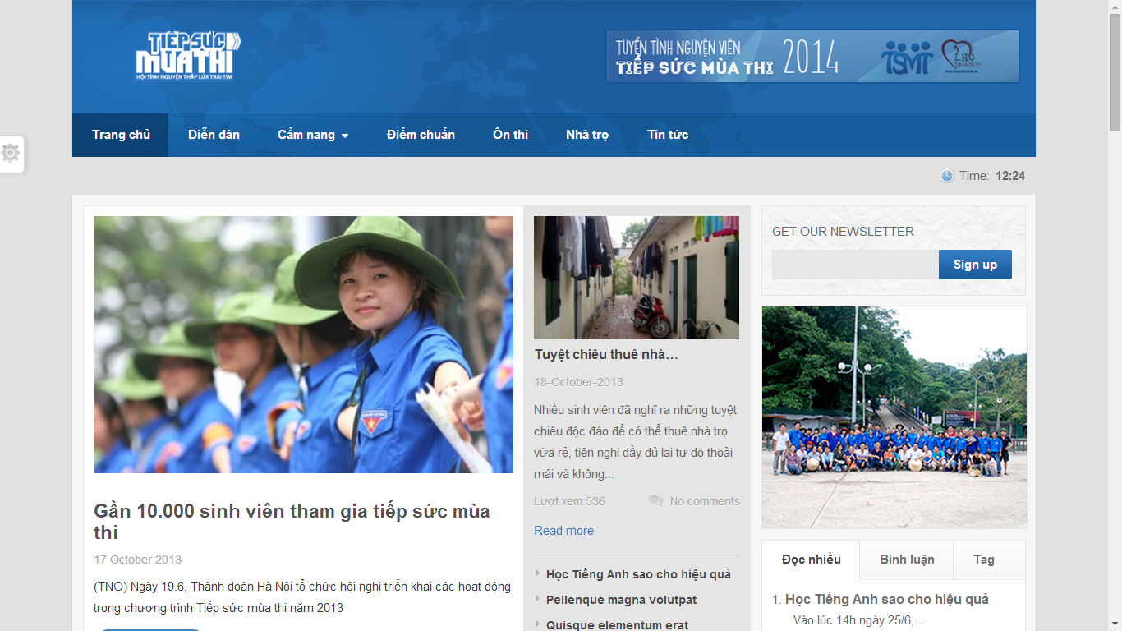

* **Advantages:**
  + Only support to candidates
  + Easy to view
* **Disadvantages:**
  + Most functions are not implemented.
  + Website is dead.
* **Website “hotrosinhvien.vn” of Student Assistance Center of Ho Chi Minh City**

That website support students, which are studying in universities, colleges. That provides student many information about lodge, scholarship, and jobs, etc…

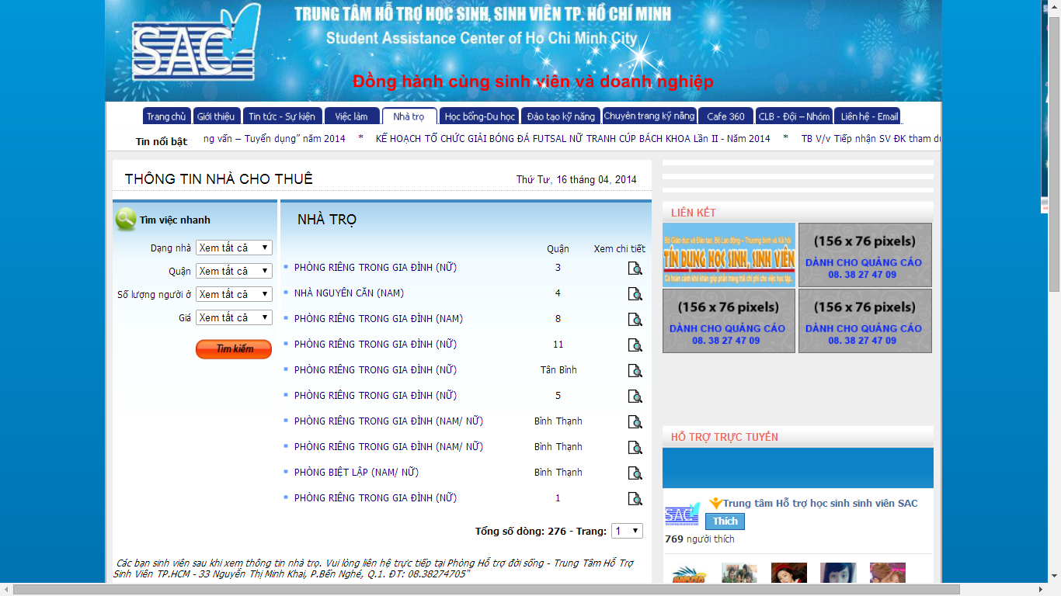

* **Advantages:**
* User can search lodges with detail information
* Providing many useful information for students in universities and colleges
* **Disadvantages:**
* Interface make user confuse because it is too many tabs.
* Not support for candidates
* Not automatically, for example, when user search lodges, then they want to choose that lodge and must contact with SAC to support.

## **Project Objective**

The project aims to develop a web-based application that

* Help volunteers and charities can register and submit their sponsor information.
* Help candidates can register and post their information and lodging request.
* The system can suggest the planning and scheduling for pickup candidates, sponsor management…

## **Scope Definition**

Following the description of project objectives, the scope of the project is constrained to the following statements:

* The users of the website should interact with the website itself through a friendly and attractive user interface.
* *For Candidates:* the website should provide functions such as: register their examination papers, find charities support, register into lodges, search friends, create groups, ask or invite friends into groups and view information about rooms, vehicles.
* *For Sponsor:* the website should allow to them create their sponsored information such as: information about lodge, vehicle, fund; give those resources to charities, and view statistic.
* *For Volunteer:* TSMT should allow them to register into charities; after charities assign candidate to pick up, they can view routes, candidate’s information
* *For Charity:* TMST should allow them to create their resources such as: lodge, vehicle; accept supported resources; assign candidates into rooms in lodges, vehicles; accept requests of volunteers.
* *For System Administrator:* TSMT should support them to monitor fundamental information about members, university, examination venue, examination schedule, and news.

## **Main Project Success Criteria**

The system meet all written specifications, be thoroughly tested and completed on time. Also, this project must be compatible with the current working process and model of FPT University.

## **Approach**

* Make survey to collect ideas from candidate, volunteer, charities which joined the campaign in the previous years.
* Use some current website to find out how it work.
* Brainstorm in our group.

## **Functions**

### **Functions for guests**

* Allow to register new account at TSMT system.
* Allow to view charities’ information, lodges
* Allow to view news about tips, lodges and new feeds.

### **Functions for candidates**

* Allow to manage their contest report cards in each exams.
* Allow to find and register into lodges, manage by charities, after registered contest report card in each exams.
* Allow to search friends, create groups, ask or invite friends to join group in each exams.
* Allow to view information about room in lodge, vehicle after charity assigned in each exams.

### **Functions for sponsors**

* Allow to manage information of their resources such as lodges, vehicles and funds.
* Allow to sponsor their resources to charities in each exams.
* Allow to view statistics about the status of using lodges, vehicles and funds.

### **Functions for charities**

* Allow to manage information about lodges, vehicles.
* Allow to register to assist and manage assistance in each exams.
* Allow to assign lodges, vehicles in each exams.
* Allow to manage volunteers, registered to support candidates.
* Allow to manage candidates, registered into lodges, sort rooms in lodges and vehicles.
* Allow to manage sponsored resources of sponsors.

### **Functions for volunteers**

* Allow to view charities’ information.
* Allow to register into charities to assist candidates in each exams.
* Allow to view route, view candidate’s information to shuttle during contest.

### **Functions for system administration**

* Allow to manage all relevant information about system.
* Allow to manage information about university, venue, and exams.
* Allow to manage news, manage categories.

## **Roles and Responsibility**

|  |  |  |  |  |
| --- | --- | --- | --- | --- |
| No. | Full Name | Role | Position | Contact |
| 1 | Nguyen Trong Tai | Supervisor | Instructor | TaiNT@fpt.edu.vn |
| 2 | Nguyen Duy Khoa | Developer, Tester | Team Leader | KhoaNDSE60769@fpt.edu.vn |
| 3 | Le Nguyen Huu Tri | Developer, Tester | Team Member | TriLNHSE60687@fpt.edu.vn |
| 4 | Tran Dinh Tuan | Developer, Tester | Team Member | TuanNDse60358@fpt.edu.vn |
| 5 | Tran Nguyen Kim Vinh | Developer, Tester | Team Member | VinhTNKSE60325@fpt.edu.vn |
| 6 | Nguyen Vinh Hien | Developer, Tester | Team Member | HienNVSE60339@fpt.edu.vn |

# **REPORT NO.2: PROJECT MANAGEMENT PLAN (PMP)**

## **Problem Definition**

### **Name of this Capstone Project**

|  |  |
| --- | --- |
| Official name | Building a website to support the activities “Tiếp sức mùa thi” campaign |
| Vietnamese name | Xây dựng website hỗ trợ các hoạt động cho chiến dịch “Tiếp sức mùa thi” |
| Abbreviation | TSMT |

### **Project Abstract**

The idea of the project is to develop a website that support candidates, which have difficult conditional in finding lodges in new environment, making group with friends, viewing support information. It also help sponsors manage their resources and assign them to charities in each exams, and know their resources are used how. It also helps volunteers know information about charities and register to assist in each exams. Finally, it help charities to manage all information about lodges, vehicles and volunteers and check all resources to support candidates in the best status.

### **Project Overview**

#### The Current System

There is not any current system. The “Tiếp sức mùa thi” campaign has some limitations like:

* Number of foundations are so much but they can’t find any easiest way to support candidates. Currently, foundations want to post their sponsor information, they must contact with SAC and wait for responding of SAC.
* The management completely done by hand-made based on a lot of paperwork, applications, and so on that lead to errors in the summary, statistics and searching.
* The most limitations is candidates can’t find any information about lodges, especially, near examination venue, if found, they also couldn’t go there easily. When candidates go to consultant locations, candidates will register their information with counselors. And volunteers will pick up candidates to the registered lodges. If lodge unfortunately is full, volunteers will take candidates to go to another lodges that spends lots of time. So, the effect of external factors will make candidates can’t focus completely on preparing for the university entrance exam.

#### The Proposed System

With TSMT System, we give users a new system that integrated the current activities process of the “Tiếp sức mùa thi” campaign by automating some functions of the traditional process.

TSMT system should support:

* Candidate can register their examination pages in each exams, then find the lodges which nearest with the venue. Moreover, candidate can search friends in lodges, to make groups to review.
* Volunteer can find charities and register their information to ask to join in those charities
* Sponsor can search and sponsored their resources (lodges, vehicles, funds) for charities in each exams
* Charity can manage sponsored resources, assign those resource in each exams, manage candidates, assign candidates into rooms in lodges, vehicles to shuttle in during exams, manage volunteers and assign volunteer to support candidates.

#### Boundaries of System

* The main scope of this project is to provide an efficiently and easy-to-use website that facilitate manually process of the “Tiếp sức mùa thi” campaign.
* It manages users, allocates suitable roles for each kind of users.
* It is not designed for specific foundation, but for general structure management of all foundation.
* The website only support Vietnamese.

#### Development Environment

Below is the list of hardware and software requirement needed for the development environment of the project

**Hardware requirements:**

* Personal computers for developing with the minimum configuration: 2 Gb of RAM, 100Gb of hard disk, Core 2 Duo 2.0 Ghz;
* A server computer for testing with the minimum configuration: 4 Gb of RAM, 100Gb of hard disk, Core 2 Duo 2.0 Ghz;
* All computers must be connected to the internet.

**Software requirements:**

* Operating system: Windows 7 or above;
* Web Server: IIS Express 7 or above;
* Framework: .NET Framework 4.5;
* IDE: Visual Studio 2012;
* DBMS: SQL Server 2008 R2;
* Source Control: SVN, Google Code.
* Others: Software Ideas Modeler, StarUML, Microsoft Office 2013 (Word, Excel, Project, Visio)

## **Project Organization**

### **Software Process Model**

With the schedule of weekly reports for every stage, the software will be developed by using waterfall model which is very simple and require minimal resource for implementation. In the waterfall approach, the whole process of software development is divided into separate phases. These phases in the model are:

* Requirement specifications phase
* System and Software design
* Implementation and Unit Testing
* Integration and System Testing
* Operation and Maintenance

Requirement Specifications

System and Software Designs

Implementation and Unit Testing

Integration and System Testing

Operation and Maintenance

Figure 1 - Software Lifecycle Model

Stages of the software waterfall lifecycle model explained:

* **Requirement Analysis and Definition**: All possible requirements of the system to be developed are captured in this phase. The requirements are gathered from the end user at the start of the software development phase. These requirements are analyzed for their validity, and the possibility of incorporating the requirements in the system to be developed is also studied. Finally, a requirement specification document is created which serves the purpose of guideline for the next phase of model.
* **System and Software Design:** The requirement specifications from the first phase are studied in this phase and a system design is prepared. System design helps in specifying hardware and system requirements and also helps in defining the overall system architecture. The system design specifications serves the purpose of guideline for the next phase of the model.
* **Implementation and Unit Testing:** On receiving system design documents, the work is divided in modules/units and actual coding is started. Each unit is developed and tested for its functionality; this is referred to as unit testing. Unit testing mainly verifies if the modules/units meet their specifications.
* **Integration and System Testing:** Units from above phrase are integrated into a complete system during integration phase and tested to check if all modules/units coordinate with each other and the system as a whole behaves as per the specifications. After successfully testing the software, it is delivered to the customer.
* **Operation and Maintenance:** Generally, problems with the system developed (which are not found during the development life cycle) come up after its practical use starts, so the issues related to the system are solved after development of the system. Not all the problems come into picture directly but they arise from time to time and need to be solved; hence. This process is referred to as maintenance.

### **Roles and Responsibilities**

|  |  |  |  |
| --- | --- | --- | --- |
| No. | Full name | Roles in group | Responsibilities |
| 1 | Nguyen Trong Tai | Supervisor | * Give advices on business and technical problems * Review and approve of project documents and product deliverables * Assess the performance of team members |
| 2 | Nguyen Duy Khoa | Team Leader, Developer, Tester | * Distribute task to the other members * Create project management plan * Monitor the development process and review the deliverables * Work on system architecture and detailed designs * Implement * Prepare documents * Perform unit testing * Deploy the final product |
| 3 | Le Nguyen Huu Tri | Team Member, Developer, Tester | * Create project management plan * Design user interfaces * Work on detailed design * Implement * Prepare documents * Perform unit testing, system testing and integration test |
| 4 | Nguyen Dinh Tuan | Team Member, Developer, Tester | * Work on detailed design * Implement * Prepare documents * Perform unit testing, system testing and integration test |
| 5 | Tran Nguyen Kim Vinh | Team Member, Developer, Tester | * Work on detailed design * Implement * Prepare documents * Perform unit testing, system testing and integration test |
| 6 | Nguyen Vinh Hien | Team Member, Developer, Tester | * Work on detailed design * Implement * Prepare documents * Perform unit testing, system testing and integration test |

### **Tools and Techniques**

The tools that will be used to develop the system includes:

* Developing tools: Microsoft Visual Studio 2012, Microsoft SQL Server 2008 R2
* Modelling tools: Software Ideas Modeler, StarUML
* Document tools: Microsoft Office 2013 (Word, Excel, Power Point, Visio, Project)
* Source control tools: SVN, Google Code

## **Project Management Plan**

### **Task**

Below are all the major tasks that need to be performed sequentially during the development of the system.

#### Task 1: Initiating

|  |  |
| --- | --- |
| Task Name | Initiating |
| Descriptions | Perform research on real situation, user’s need research; decide upon the technology that will be used to develop the system |
| Deliverables | Report 1 – Project Introduction |
| Resources needed | 6 days |
| Dependencies and constraints | N/A |
| Risks | * Team members did not know each other in advance and have a little background in term of “Tiếp sức mùa thi” campaign * Some users may not agree to spend time for making surveys * Strange requirement from users * Lack of technologies or chosen technologies are not feasible |

#### Task 2: Planning

|  |  |
| --- | --- |
| Task Name | Planning |
| Descriptions | Create the project management plan; break the system into modules and assign tasks to each member. |
| Deliverables | Report 2 – Software Project Management Plan |
| Resources needed | 6 days |
| Dependencies and constraints | Task 1 has finished |
| Risks | * Team leader has no experience in managing software projects; all members are still not acquainted with the new technology. * Dividing modules and planning tasks maybe unbalance, and unreasonable |

#### Task 3: Creating Software Requirement Specification

|  |  |
| --- | --- |
| Task Name | Creating Software Requirement Specification |
| Descriptions | Discuss and agree upon the software requirements, what is to be developed and what is not; generate detailed descriptions of all the functions to be developed. |
| Deliverables | * Planning process has to be finished * Follow the Software Requirement Specification template |
| Resources needed | 12 days |
| Dependencies and constraints | Task 2 has finished |
| Risks | * Many aspects of the problem are still unclear to team members * All requirements come from team members, so conflicts may happen regularly * Misunderstand between user requirements and receiving information from designer may make designing and developing phrases be failed. |

#### Task 4: Designing Database

|  |  |
| --- | --- |
| Task Name | Designing database |
| Descriptions | Design the database based on the requirements collected, through three major steps: Conceptual, Logical, and Physical Design |
| Deliverables | ERD and the physical database with sample data |
| Resources needed | All team members; 4 days |
| Dependencies and constraints | Finish the requirement and specification phrase |
| Risks | Some of the requirements specified are not clear and cannot be translated into corresponding entities; little experience in organizing data. |

#### Task 5: Designing User Interface

|  |  |
| --- | --- |
| Task Name | Designing User Interface |
| Descriptions | * Design layouts for each page in system * Design style for each page in the system. * Design connection between all pages in the system * Define some basic JavaScript for each file |
| Deliverables | Prototype which includes:   * HTML pages * CSS files * JavaScript file |
| Resources needed | 6 days |
| Dependencies and constraints | * Finish the requirement specification task * User Interface must be friendly, easy to see and suitable with all functions in the system and topic of this project. * Display well in screen resolution 1024 x 768 |
| Risks | User interface may completely satisfy all dependencies and constrains above. |

#### Task 6: Creating Software Design Description

|  |  |
| --- | --- |
| Task Name | Creating Software Design Description |
| Descriptions | Agree upon the system architecture; Work on the detailed design of each module; decide which techniques are appropriate to which modules; design the user interfaces for users to interact with. |
| Deliverables | Report 4 – Software Design Description |
| Resources needed | 12 days |
| Dependencies and constraints | * Finish Software Requirement Specification report * Follow Software Design Description (SDD) report template |
| Risks | * Some functions are difficult to find an appropriate methods to implement; initial development environment setup is also difficult. * SRS may not detailed enough in other to meet business logic * Designing work is not good which lead to occur problem when implement, such as spending much effort for coding, maintain hard. |

#### Task 7: Creating Coding Framework

|  |  |
| --- | --- |
| Task Name | Creating Coding Framework |
| Descriptions | * Mapping the architecture design into source code * Create project solution files with: * Common classes * Common functions |
| Deliverables | ASP.NET MVC4 project and solution files |
| Resources needed | 4 days |
| Dependencies and constraints | * Finish Software Design Description (SDD) report * Follow coding convention |
| Risks | * Having bugs when coding framework * Team members do not understand thoroughly framework * Problem about coding skill which is not follow coding convention * Actual time may be more time than estimated time |

#### Task 8: Implementing

|  |  |
| --- | --- |
| Task Name | Implementing |
| Descriptions | Each team member implement all the functions that he or she was assigned and regularly check in the code to the SVN into Google Code; regularly validate that the implementation is consistent with the system and detailed designs. |
| Deliverables | The implemented website |
| Resources needed | All team members; 27 days |
| Dependencies and constraints | Task 7 has finished |
| Risks | * Some design documents contain errors; implementation is not always consistent with the system and detailed designs. * Team members do not understand thoroughly framework * Problem about coding skill which is not follow coding convention |

#### Task 9: Preforming System Testing

|  |  |
| --- | --- |
| Task Name | Performing System Testing |
| Descriptions | Create and perform appropriate test cases for all main functions; record the test results for later reference; fix all the bugs found during the testing sessions. |
| Deliverables | Report 5 – Software Test Documentation |
| Resources needed | 12 days |
| Dependencies and constraints | Task 8 has finished |
| Risks | Lack of test cases for some non-critical functions; not enough time to intensively test all the functions. |

#### Task 10: Deployment and Input Initial Data

|  |  |
| --- | --- |
| Task Name | Deployment and Input Initial Data |
| Descriptions | Deploy system and input initial data for TSMT system |
| Deliverables | Complete TSMT project source code, up-to-date documentations. |
| Resources needed | 8 days |
| Dependencies and constraints | Task 9 has finished |
| Risks | * Update all documentations may need more time than schedule. * Team members may not familiar with input consistent data for all tables in database. * The program is not running properly in real environment. * Cannot release before the deadline. |

#### Task 11: Writing User’s Manual

|  |  |
| --- | --- |
| Task Name | Writing User’s Manual |
| Descriptions | Writing a user’s manual to instruct the users, including guest, travelers, hotel owners, and system administrators, how to use the system. |
| Deliverables | Report 6 – User’s Manual |
| Resources needed | 4 days |
| Dependencies and constraints | Task 9 has finished |
| Risks | * Some of the functions are not consistent with the user requirements, causing the user’s manual to be inconsistent with the user requirements. * User’s manual may be not easy to understand with the customer. * Team members may be not familiar with crating user’s manual which leads to behind schedule. |

### **Task Sheet: Assignments and Timetable**

|  |  |  |  |  |
| --- | --- | --- | --- | --- |
| Task Name | Duration | Start Date | End Date | Resource |
| Initiating | 5 days | Mon 06/01/2014 | Fri  10/01/2014 | KhoaND, TriLNH, TuanND, VinhNTK, HienNV |
| Planning | 5 days | Mon 13/01/2014 | Fri  17/01/2014 | KhoaND, TriLNH |
| Creating Software Requirement Specification | 5.5 days | Mon 20/01/2014 | Fri  24/01/2014 | TuanND, VinhNTK, HienNV |
| Designing Database | 1.5 days | Fri  24/01/2014 | Mon  27/01/2014 | KhoaND, TriLNH |
| Designing User Interface | 3 days | Mon  10/02/2014 | Thu  13/02/2014 | TriLNH, TuanND, VinhNTK |
| Creating Software Design Description | 3 days | Fri  14/02/2014 | Tue  18/02/2014 | TriLNH, TuanND, VinhNTK, HienNV |
| Creating Coding Framework | 3 days | Wed  19/02/2014 | Fri  21/02/2014 | KhoaND, HienNV |
| Implementing | 27 days | Fri  28/02/2014 | Mon  07/04/2014 | KhoaND, TriLNH, TuanND, VinhNTK, HienNV |
| Performing System Test | 3 days | Tue  08/04/2014 | Thu  10/04/2014 | TriLNH, TuanND, VinhNTK, HienNV |
| Creating Software User’s Manual | 4 days | Fri 11/04/2014 | Wed  16/04/2014 | TriLNH, TuanND, VinhNTK |
| Deploying and Inputting Initial Data | 2 days | Thu  17/04/2014 | Fri  18/04/2014 | KhoaND, HienNV |

## **Convention Rules**

The implantation of the system must strictly follow all the standard coding and naming convention specified by Microsoft, which can be found at <http://msdn.microsoft.com/en-us/library/ff926074.aspx>

# **REPORT NO.3: SYSTEM REQUIREMENT SPECIFICATION (SRS)**

## **User Requirement Specification**

The system should allow types of actors, namely Guest, Candidate, Sponsor, Charity, Volunteer and Admin. And an abstract actor names Authorized User.

### **Guest Requirements**

A guest is an authenticated user of the website. He or she can:

* Search charity in each examinations
* View detail information of charity
* View news
* View news feeds
* View system statistics
* Register

### **Authorized User Requirements**

An authorized user (who logged on to the system with a valid email and password) can:

* Log in
* Log out
* Change password
* Reset password
* View and update detail account profile

Note: This actor is an abstract one and does not represent a real actor in practical

### **Candidate Requirements**

A candidate is an authorized user (see 3.1.2. Authorized User Requirement) and is given all the function of a guest (see 3.1.1. Guest Requirement). A candidate also has his or her own set of functions:

* Manage Examination Paper
* Register or unregister at charities
* Search friends which stay
* Invite friends, in the same lodge, for joining a group
* Ask to join a group
* Approve or deny a request

### **Sponsor Requirements**

A sponsor is an authorized user (see 3.1.2. Authorized User Requirement) and is given all the function of a guest (see 3.1.1. Guest Requirement). A sponsor also has his or her own set of functions:

* Manage vehicles of sponsor
* Manage lodges of sponsor
* Manage rooms of lodges of sponsor
* Manage funds
* Sponsored resources for charity
* View statistics for sponsor

### **Charity Requirements**

A charity is an authorized user (see 3.1.2. Authorized User Requirement) and is given all the function of a guest (see 3.1.1. Guest Requirement). A charity also has his or her own set of functions:

* Manage vehicles of charity
* Manage lodges of charity
* Manage room of lodges of charity
* Manage examinations which charity registered to support
* Manage candidates which registered to stay at a lodge of charity in each exams
* Manage volunteers which registered with charity to support candidates in each exams
* Manage resources in each exams include: vehicles, lodges, rooms, and resources which are sponsored (lodges, vehicles, funds).
* Assign rooms for candidates in each exams
* Assign vehicles for candidates to shuttle in during exams
* Manual assign rooms, vehicles for candidates who can’t assign into rooms, vehicles in automatic mode.
* View statistics for charity

### **Volunteer Requirements**

A volunteer is an authorized user (see 3.1.2. Authorized User Requirement) and is given all the function of a guest (see 3.1.1. Guest Requirement). A volunteer also has his or her own set of functions:

* Register to charities. In each exams, volunteer only can register a charity
* View route and view schedule to shuttle candidate during examination days
* Manage news

### **Administrator Requirements**

An administrator is an authorized user (see 3.1.2. Authorized User Requirement) and is given all the function of a guest (see 3.1.1. Guest Requirement). An administrator also has his or her own set of functions:

* Manage accounts
* Manage categories
* Manage posts
* Approve posts
* Manage information of universities
* Manage examination schedule
* Manage university – examination. It allows admin to create information about examination of university
* Manage examination venues in each exams

## **System Requirement Specification**

### **External Interface Requirement**

#### User Interfaces

* The TSMT website should adopt an attractive and user-friendly interface so that the users of the system can get a good experience browsing the site.
* The pages should be well linked together to promote
* Client postbacks should be limited wherever possible, in order to boost performance and ease of use
* The languages of TSMT website is Vietnamese.

#### Hardware Interfaces

* The TSMT website can be reached by personal computers that support Internet connection and web browsers. In order to get the best experience, the following conditions should be satisfied:
* 512 Kbps Internet connection or faster
* 1 gigahertz (GHz) processor or faster
* 1 gigabytes (GB) RAM or more.

#### Software Interfaces

|  |  |  |  |
| --- | --- | --- | --- |
| Software Name | Version | Cost | Provider |
| Web Browser   * Internet Explorer * Mozilla Firefox * Google Chrome | 9.0 or higher  27.0 or higher  34 | Free  Free  Free | Microsoft  Mozilla  Google |
| SQL Server Express | 11.0 | Free | Microsoft |
| .NET Framework | 4.5 | Free | Microsoft |
| IIS Express | 8 | Free | Microsoft |

### **System Features**

#### Overall Use case diagram

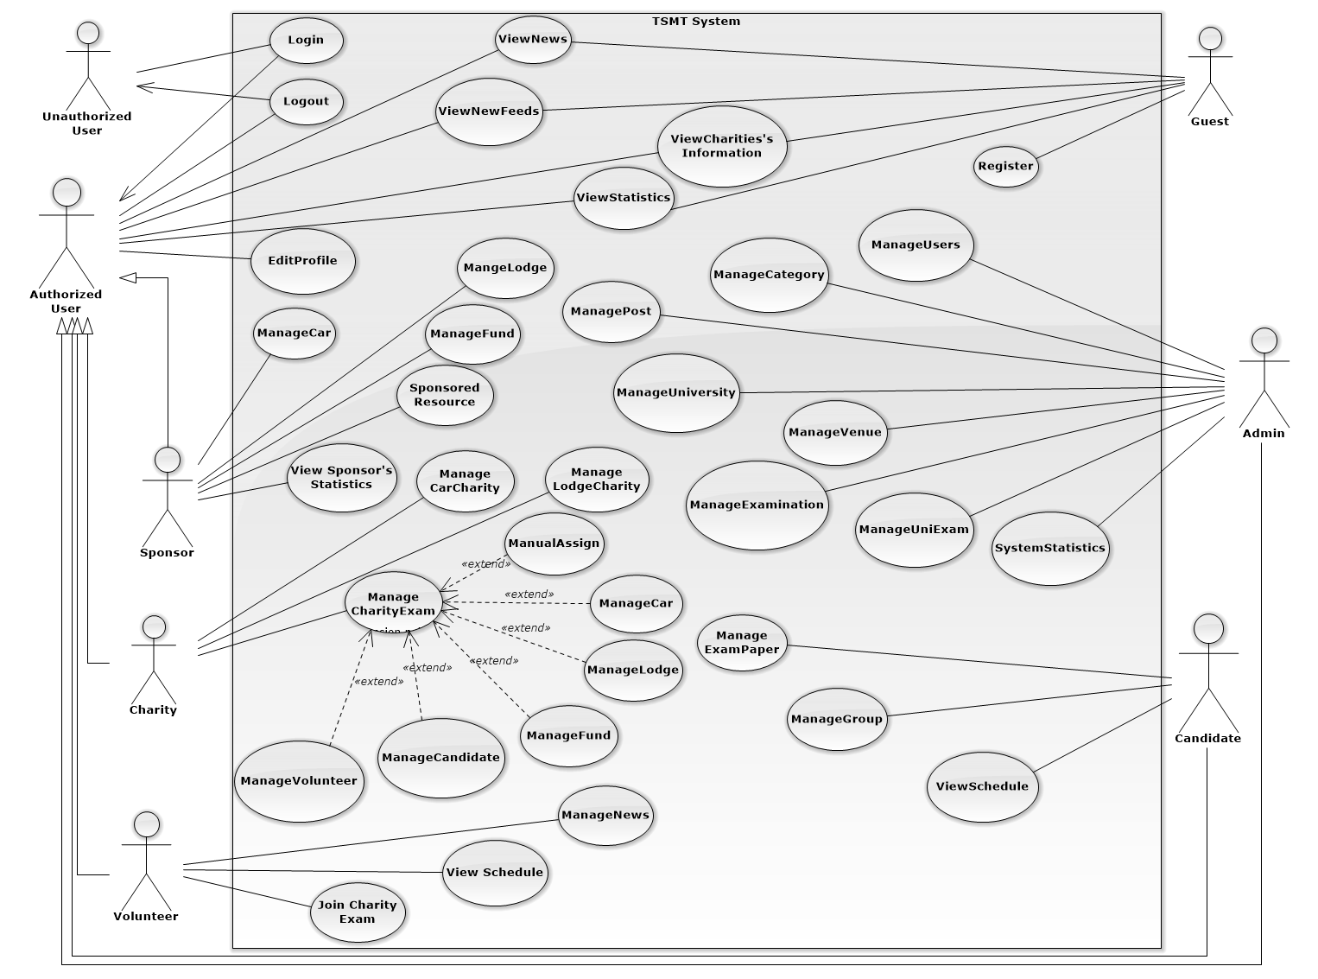Figure 2 - System Overview Usecase

#### (Guest) Register

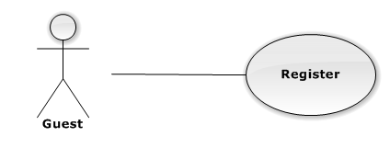

|  |  |  |  |  |
| --- | --- | --- | --- | --- |
| **USE CASE-UC001 SPECIFICATION** | | | | |
| **Use-case No.** | UC001 | **Use-case Version** | | 1.0 |
| **Use-case Name** | Register | | | |
| **Author** | Nguyễn Đình Tuấn | | | |
| **Date** | 15/02/2014 | **Priority** | Normal | |
| **Actor:**  Guest  **Summary:**  Guest can register new account  **Goal:**  It helps guest to register new account  **Triggers:**  Guest click “Đăng ký” on the homepage .  **Preconditions:**  The page is fully loaded  Guest link to TSMT page  **Post Conditions:**  *On success:* Message box will be shown “Bạn đã đăng ký thành công” and go to Homepage  *On failure:* An error message is displayed. The content of the error message will be specified in the Exception Scenario section based on the type of failure.  **Main Success Scenario:**   |  |  |  | | --- | --- | --- | | **Step** | **User Action** | **System Response** | | 1. | Click “tạo tài khoản” on the home page |  | | 2. |  | Display a table with profile information of User   * Tên đăng nhập: textbox (min length: 5, max length: 30, required). * Ngày sinh: textbox (min length: 5, max length: 30). * Giới tính: textbox (min length: 5, max length: 30). * Email: textbox (min length: 5, max length: 30, required). * Địa chỉ: textbox (min length: 5, max length: 50, required). * Điện thoại: textbox (min length: 5, max length: 30,). * Mật khẩu: textbox (min length: 5, max length: 30, required). | | 3 | Fills out the form with relevant values. |  | | 4 | Click “Tạo tài khoản” to create new account |  | | 5 |  | Show confirmation message: “Tạo tài khoản thành công” redirects the user to the home page of this role |   **Alternative Scenario: N/A**  **Exceptions:**   |  |  |  | | --- | --- | --- | | No | Actor Action | System Response | | 1 | No input in (“Tên Đăng Nhập”,“Mật khẩu”, “Email”, “Địa chỉ” textboxs | Show error message: “Vui lòng điền đầy đủ thông tin bên dưới” below Username/Password/Email/Address textbox. | | 2 | Username/Password not in range [5,30] | Show error message: “Tên Đăng Nhập/ Mật Khẩuphải từ 5 đến 30 kí tự” textbox. |   **Relationships: N/A**  **Business Rules: N/A** | | | | |

#### (Authorized User) Edit Profile

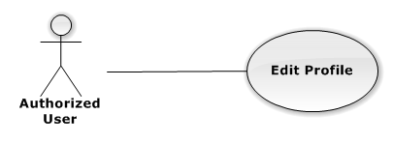

|  |  |  |  |  |
| --- | --- | --- | --- | --- |
| **USE CASE-UC003 SPECIFICATION** | | | | |
| **Use-case No.** | UC003 | **Use-case Version** | | 1.0 |
| **Use-case Name** | Edit Profile | | | |
| **Author** | Nguyễn Đình Tuấn | | | |
| **Date** | 15/02/2014 | **Priority** | Normal | |
| **Actor:**  Authorized User(sponsor, charity, candidate, volunteer, admin)  **Summary:**  Authorized user can edit the information need, to supplement incomplete information at registration step.  **Goal:**  It helps Authorized User to edit profile  **Triggers:**  Authorized User wants to edit profile.  Authorized User click “Edit Profile” on the individual menu which has “Edit” status  **Preconditions:**  The page is fully loaded  User log in with “Authorized User” role.( sponsor, charity, candidate, volunteer, admin)  Stay at Homepage.  **Post Conditions:**  *On success:* Message box will be shown “Bạn đã thay đổi thông tin cá nhân!” and go to Homepage  *On failure:* An error message is displayed. The content of the error message will be specified in the Exception Scenario section based on the type of failure..  **Main Success Scenario:**   |  |  |  | | --- | --- | --- | | **Step** | **User Action** | **System Response** | | 1. | Click “chỉnh sữa thông tin cá nhân” tab to view basic information |  | | 2. |  | Display a table with profile information of authorized User   * Tên: textbox (min length: 5, max length: 30, required). * Ngày sinh: textbox (min length: 5, max length: 30). * Giới tính: textbox (min length: 5, max length: 30). * Email: textbox (min length: 5, max length: 30, required). * Địa chỉ: textbox (min length: 5, max length: 50, required). * Điện thoại: textbox (min length: 5, max length: 30,). * Mật khẩu: textbox (min length: 5, max length: 30, required). | | 3 | Changes the existing information with relevant values. |  | | 4 | Click “Lưu” to Update information |  | | 5 |  | Show confirmation message: “Bạn có muốn lưu thông tin này?” with “Xác Nhận” button and “Hủy” button. [See Alternative 1] | | 6 | Click “Xác nhận” button to cancel update. |  | | 7 |  | Close info message box, update new information and back to Home page |   **Alternative Scenario:**   |  |  |  |  | | --- | --- | --- | --- | | **No** | **Step** | **User Action** | **System Response** | | 1. | 1. | Click “Hủy” button. |  | |  | 2. |  | Close info message box and back to Home page |   **Exceptions:**   |  |  |  | | --- | --- | --- | | No | Actor Action | System Response | | 1 | No input in (“Tên Đăng Nhập”,“Mật khẩu”, “Email”, “Địa chỉ” textboxs | Show error message: “Vui lòng điền đầy đủ thông tin bên dưới” below Username/Password/Email/Address textbox. | | 2 | Username/Password not in range [5,30] | Show error message: “Tên Đăng Nhập/ Mật Khẩu phải từ 5 đến 30 kí tự” textbox. |   **Relationships:**  Login  **Business Rules:**  N/A | | | | |

#### (Authorized) Change Password

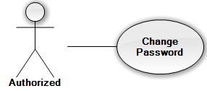

|  |  |  |  |  |
| --- | --- | --- | --- | --- |
| **USE CASE-UC004 SPECIFICATION** | | | | |
| **Use-case No.** | UC004 | **Use-case Version** | | 1.0 |
| **Use-case Name** | Change Password | | | |
| **Author** | Nguyễn Đình Tuấn | | | |
| **Date** | 13/2/2014 | **Priority** | High | |
| **Actor:** User (sponsor, charity, candidate, volunteer, admin).  **Summary:**  User users this case to change their password.  **Goal:** Allow users can change their password.  **Triggers:**   * User use this use case to help improve their account security. * User login their account, click “Change Password” link. Go to “Change Password” page.   **Preconditions:**   * User must logged in the system with the role is User (sponsor, charity, candidate, volunteer, admin).   **Post Conditions:**  *On success:* The password be changed.  *On failure:* An error message is displayed. The content of the error message will be specified in the Exception Scenario section based on the type of failure.  **Main Success Scenario:**   |  |  |  | | --- | --- | --- | | **Step** | **User Action** | **System Response** | | 1. | User selects the “Đổi mật khẩu” command in the top-right column of Home page. |  | | 2. |  | System will show “Đổi mật khẩu” page includes:   * Tài khoản – Text box * Mật khẩu hiện tại – Text box * Mật khẩu mới– Text box * Xác Nhận Mật Khẩu – Text box * Thay Đổi – Button * Làm mới - Button | |  | - User enters the following information (Tài khoản, Mật khẩu hiện tại, Mật khẩu mới, Xác Nhận Mật Khẩu).  - Click “Thay đổi” button to send request. |  | |  |  | * System changes the user’s password. * System automatically re-authenticates the user with the new credentials.   System will show “mật khẩu của bạn đã thay đổi thành công!” |   **Alternative Scenario:** N/A  **Exceptions:**   |  |  |  | | --- | --- | --- | | Step | Actor Action | System Response | | 1 | System verifies that the Username and Current Password entries are correct and correspond to a current user. | System will show “Sai tên đăng nhập/ mật khẩu” and reset all. | | 2 | New password same current password | System will show “Mật khẩu mới đã từng được sử dụng, vui lòng nhập mật khẩu khác” and reset all. | | 3 | New password and confirm new password does not match. | System will show “mật khẩu kho6gn trùng khớp” and reset all. |   **Relationships: N/A**  **Business Rules:N/A** | | | | |

#### (Authorized) Logout

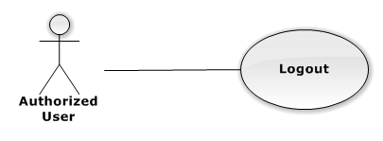

|  |  |  |  |
| --- | --- | --- | --- |
| **USE CASE-UC005 SPECIFICATION** | | | |
| **Use Case No.** | UC005 | **Use Case Version** | 2.0 |
| **Use Case Name** | logout | | |
| **Author** | Nguyễn Đình Tuấn | | |
| **Date** | 23/09/2013 | **Priority** | Normal |
| **Actor:** User (sponsor, charity, candidate, volunteer, admin).  **Summary:**   * User use this use case to logout system.   **Goal:**   * The user selects the option to log off of the TSMT website and is then redirected back to the Login page.   **Triggers:**   * The use case starts when the user selects the option to logout. * The user selects the option to logout. * The system informs the user of logging out. * The user confirms logging out. * The system redirects user back to the Login page.   **Preconditions:**   * User must logged in the system with the role is User (sponsor, charity, candidate, volunteer, admin).   **Post Conditions:**   * **Success**: User logout system and redirect to login page. * **Fail:** System will transfer to error page or still in current page.   **Main Success Scenario:**   |  |  |  | | --- | --- | --- | | Step | Actor Action | System Response | | 1 | The user selects log out. | The system will show a pop-up: Bạn có muốn thoạt khỏi hệ thống”   * Xác nhận: button * Hủy: button | | 2 | User select “Xác Nhận”.  [Alternative 1] | The system will clear user session and the user is logged out |   **Alternative Scenario:**   |  |  |  | | --- | --- | --- | | Step | Actor Action | System Response | | 1 | User selects Hủy. | User stay at current page. |   **Exceptions:** N/A  **Relationships:** N/A  **Business Rules:** N/A | | | |

#### (Guest) View Charity

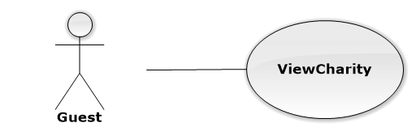

|  |  |  |  |  |
| --- | --- | --- | --- | --- |
| **USE CASE-UC006 SPECIFICATION** | | | | |
| **Use-case No.** | UC006 | **Use-case Version** | | 1.0 |
| **Use-case Name** | View charity | | | |
| **Author** | Nguyễn Đình Tuấn | | | |
| **Date** | 13/2/2014 | **Priority** | High | |
| **Actor:** Guest  **Summary:**  This use case is about how to view charity  **Goal:** Guest can view charity.  **Triggers:**  In “Home” page, guest clicks “Các Hội Từ Thiện”.  **Preconditions:** Guest is already link to “Tiếp Sức Mùa Thi” website  **Post Conditions:**  *On success:* Guest can view charity successful.  *On failure:* An error message is displayed. The content of the error message will be specified in the Exception Scenario section based on the type of failure.  **Main Success Scenario:**   |  |  |  | | --- | --- | --- | | **Step** | **User Action** | **System Response** | | 1. | In the Home page, user clicks “ Các Hội Từ Thiện” |  | | 2. |  | System will redirect to”View Detail Charity” with detail information of charity |   **Alternative Scenario:** N/A  **Exceptions: N/A**  **Relationships: N/A**  **Business Rules:N/A** | | | | |

#### (Guest) View Detail Charity

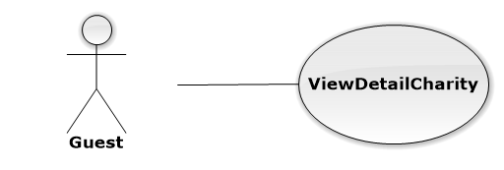

|  |  |  |  |  |
| --- | --- | --- | --- | --- |
| **USE CASE-UC007 SPECIFICATION** | | | | |
| **Use-case No.** | UC007 | **Use-case Version** | | 1.0 |
| **Use-case Name** | View detail charity | | | |
| **Author** | Nguyễn Đình Tuấn | | | |
| **Date** | 13/2/2014 | **Priority** | High | |
| **Actor:** Guest  **Summary:**  This use case is about how to view detail charity  **Goal:** Guest can view detail charity.  **Triggers:**  In “View Charity” page, guest clicks “Xem Chi tiết”.  **Preconditions:** The guest is already link to “Tiếp Sức Mùa Thi” website  **Post Conditions:**  *On success:* Guest can view detail charity successful.  *On failure:* An error message is displayed. The content of the error message will be specified in the Exception Scenario section based on the type of failure.  **Main Success Scenario:**   |  |  |  | | --- | --- | --- | | **Step** | **User Action** | **System Response** | | 1. | In the View Charity page, guest clicks “ Xem Chi tiết” |  | | 2. |  | System will redirect to”View Charity”  Displays a form that has the following item:   * “Các hội từ thiện trong kỳ thi” (selectbox; required; max length 50) | | 3. | Guest click choose charity to view |  | |  |  | Displays page with information of charity |   **Alternative Scenario:** N/A  **Exceptions: N/A**  **Relationships: N/A**  **Business Rules: N/A** | | | | |

#### (Guest) View News



|  |  |  |  |  |
| --- | --- | --- | --- | --- |
| **USE CASE-UC008 SPECIFICATION** | | | | |
| **Use-case No.** | UC008 | **Use-case Version** | | 1.0 |
| **Use-case Name** | View news | | | |
| **Author** | Nguyễn Đình Tuấn | | | |
| **Date** | 13/2/2014 | **Priority** | High | |
| **Actor:** Guest  **Summary:**  This use case is about how to view news  **Goal:** Guest can view news  **Triggers:**  In “Home” page, guest clicks “Tin tức”.  **Preconditions:** The guest is already link to “Tiếp Sức Mùa Thi” website  **Post Conditions:**  *On success:* Guest can view news successful.  *On failure:* An error message is displayed. The content of the error message will be specified in the Exception Scenario section based on the type of failure.  **Main Success Scenario:**   |  |  |  | | --- | --- | --- | | **Step** | **User Action** | **System Response** | | 1. | In the Home page, guest clicks “ Tin Tức” |  | | 2. |  | System will redirect to”View News” with all news in the web |   **Alternative Scenario:** N/A  **Exceptions: N/A**  **Relationships: N/A**  **Business Rules:N/A** | | | | |

#### (Guest) Get New Feed

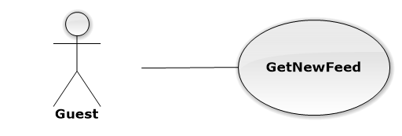

|  |  |  |  |  |
| --- | --- | --- | --- | --- |
| **USE CASE-UC009 SPECIFICATION** | | | | |
| **Use-case No.** | UC009 | **Use-case Version** | | 1.0 |
| **Use-case Name** | Get New Feed | | | |
| **Author** | Nguyễn Đình Tuấn | | | |
| **Date** | 13/2/2014 | **Priority** | High | |
| **Actor:** Guest  **Summary:**  This use case is about how to get new feed  **Goal:** Guest can get new feed  **Triggers:**  In “News” page, guest clicks “Xem tin tức từ trang báo khác”.  **Preconditions:** The guest is already link to “Tiếp Sức Mùa Thi” website  **Post Conditions:**  *On success:* Guest can get new feed successful.  *On failure:* An error message is displayed. The content of the error message will be specified in the Exception Scenario section based on the type of failure.  **Main Success Scenario:**   |  |  |  | | --- | --- | --- | | **Step** | **User Action** | **System Response** | | 1. | In the News page, guest clicks “ Xem tin tức từ trang báo khác” |  | | 2. |  | System will redirect to”Get New Feed” with all news in the web |   **Alternative Scenario:** N/A  **Exceptions: N/A**  **Relationships: N/A**  **Business Rules: N/A** | | | | |

#### (Admin) Manage University

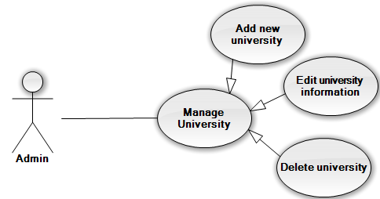

#### (Admin) Manage University – Add new university

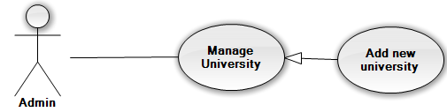

|  |  |  |  |  |
| --- | --- | --- | --- | --- |
| **USE CASE-UC010 SPECIFICATION** | | | | |
| **Use-case No.** | UC010 | **Use-case Version** | | 1.0 |
| **Use-case Name** | Add new university | | | |
| **Author** | Trần Nguyễn Kim Vinh | | | |
| **Date** | 13/2/2014 | **Priority** | Normal | |
| **Actor:** Admin  **Summary:**  This use case allows admin can create new university.  **Goal:** Create new university in database.  **Triggers:**  In manage university page of admin, user click “Tạo mới”.  **Preconditions:** The user is already logged in with an account in admin role. The manage university is being display.  **Post Conditions:**  *On success:* A new university is added into database.  *On failure:* An error message is displayed. The content of the error message will be specified in the Exception Scenario section based on the type of failure.  **Main Success Scenario:**   |  |  |  | | --- | --- | --- | | **Step** | **User Action** | **System Response** | | 1. | Click button “Tạo mới” in dashboard of page. |  | | 2. |  | Displays a form that has the following items:   * “Tên trường” (textbox; required; min length 3; max length 100) * “Địa chỉ” (textbox; required; min length 3; max length 150) * “Mã trường” (textbox; required; min length 3; max length 50) * “Website” (textbox;not required; min length 3; max length 50) * “Số điện thoại” (textbox;not required) | | 3. | Fills out the form with relevant values. |  | | 4. | Clicks the button “Lưu lại”. |  | | 5. |  | Saves the new university information to the database, redirects the user to the manage university page. |   **Alternative Scenario: N/A**  **Exceptions:**   |  |  |  | | --- | --- | --- | | **No** | **User Action** | **System Response** | | 1. | Input same university code with an existing university in database  Click “Tạo” button. | Shows error message at start date: “Trường này đã được tạo”. | | 2. | Don’t input anything or input missing require fields? Click “Tạo” button. | Show error message at one or all require fields. |   **Relationships:** Manage university  **Business Rules:** Cannot add new university have name or university code as same as the university exist in database | | | | |

#### (Admin) Manage University – Edit university information

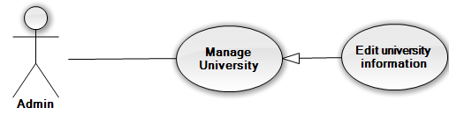

|  |  |  |  |  |
| --- | --- | --- | --- | --- |
| **USE CASE-UC011 SPECIFICATION** | | | | |
| **Use-case No.** | UC011 | **Use-case Version** | | 1.0 |
| **Use-case Name** | Edit university information | | | |
| **Author** | Trần Nguyễn Kim Vinh | | | |
| **Date** | 13/2/2014 | **Priority** | Normal | |
| **Actor:** Admin  **Summary:**  This use case allows admin can edit existing university information.  **Goal:** Edited university information exist in database.  **Triggers:**  In manage university page of admin, user click button imaged as edit.  **Preconditions:** The user is already logged in with an account in admin role. The manage university is being display.  **Post Conditions:**  *On success:* The selected university is updated in database. The user redirected to manage university page.  *On failure:* An error message is displayed. The content of the error message will be specified in the Exception Scenario section based on the type of failure.  **Main Success Scenario:**   |  |  |  | | --- | --- | --- | | **Step** | **User Action** | **System Response** | | 1. | Click button edit at the row of university user want to edit in dashboard of page. |  | | 2. |  | Displays all information of the selected university and filled in form that has the following items:   * “Tên trường” (textbox; required; min length 3; max length 100) * “Địa chỉ” (textbox; required; min length 3; max length 150) * “Mã trường” (textbox; required; min length 3; max length 50) * “Website” (textbox;not required; min length 3; max length 50) * “Số điện thoại” (textbox;not required) | | 3. | Changes the existing information with relevant values. |  | | 4. | Clicks the button “Lưu”. |  | | 5. |  | Saves the university information to the database, redirects the user to the manage university page. |   **Alternative Scenario: N/A**  **Exceptions: N/A**  **Relationships: N/A**  **Business Rules:** N/A | | | | |

#### (Admin) Manage University – Delete University

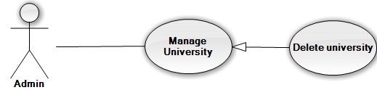

|  |  |  |  |  |
| --- | --- | --- | --- | --- |
| **USE CASE-UC012 SPECIFICATION** | | | | |
| **Use-case No.** | UC012 | **Use-case Version** | | 1.0 |
| **Use-case Name** | Delete university | | | |
| **Author** | Trần Nguyễn Kim Vinh | | | |
| **Date** | 13/2/2014 | **Priority** | Low | |
| **Actor:** Admin  **Summary:**  This use case allows admin can delete a selected university.  **Goal:** Deleted selected university from database.  **Triggers:**  In manage post page of admin, user click button delete at university user want delete.  **Preconditions:** The user is already logged in with an account in admin role. The manage university is being display.  **Post Conditions:**  *On success:* University is deleted from database.  *On failure:* An error message is displayed. The content of the error message will be specified in the Exception Scenario section based on the type of failure.  **Main Success Scenario:**   |  |  |  | | --- | --- | --- | | **Step** | **User Action** | **System Response** | | 1. | Click button delete on the row that contains the university to be deleted. |  | | 2. |  | Shows a popup to ask the user to confirm the action. | | 3. | Click “OK” to continue to delete the university. |  | | 4. |  | Marks the selected university as deleted in the database and redirect to manage university page. |   **Alternative Scenario:**   |  |  |  |  | | --- | --- | --- | --- | | **No** | **Step** | **User Action** | **System Response** | | 1. | 1. | Clicks on the button “Hủy bỏ”. |  | | 2. |  | Hides the popup message. |   **Exceptions: N/A**  **Relationships: N/A**  **Business Rules**: If a university have assigned to a university exam, user cannot delete that university | | | | |

#### (Admin) Manage Examination

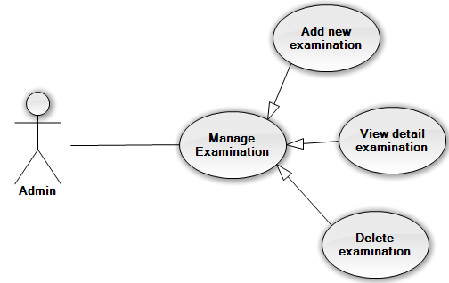

#### (Admin) Manage Examination – Add new examination

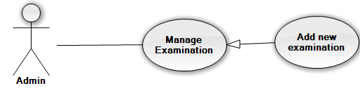

|  |  |  |  |  |
| --- | --- | --- | --- | --- |
| **USE CASE-UC013 SPECIFICATION** | | | | |
| **Use-case No.** | UC013 | **Use-case Version** | | 1.0 |
| **Use-case Name** | Add new examination | | | |
| **Author** | Trần Nguyễn Kim Vinh | | | |
| **Date** | 13/2/2014 | **Priority** | Normal | |
| **Actor:** Admin  **Summary:**  This use case allows admin can create new examination.  **Goal:** Create new examination in database.  **Triggers:**  In manage examination page of admin, user click “Tạo mới”.  **Preconditions:**   * The user is already logged in with an account in admin role. * The manage examination is being display.   **Post Conditions:**  *On success:* A new examination is added into database.  *On failure:* An error message is displayed. The content of the error message will be specified in the Exception Scenario section based on the type of failure.  **Main Success Scenario:**   |  |  |  | | --- | --- | --- | | **Step** | **User Action** | **System Response** | | 1. | Click button “Tạo mới” in dashboard of page. |  | | 2. |  | Displays a form that has the following items:   * “Tên đợt thi” (textbox; required; max length 50) * “Ngày bắt đầu” (date time; required, require start date is date in future) * “Ngày kết thúc” (date time; required; end date must be larger than start date) | | 3. | Fills out the form with relevant values. |  | | 4. | Clicks the button “Tạo”. |  | | 5. |  | Saves the new examination information to the database, redirects the user to the manage examination page. |   **Alternative Scenario: N/A**  **Exceptions:**   |  |  |  | | --- | --- | --- | | **No** | **User Action** | **System Response** | | 1. | Input start date and end date same with existed examination.  Click “Tạo” button. | Shows error message at start date and end date: “Đợt thi này đã được tạo, Vui long tạo đợt thi khác” | | 2. | Input start date larger than end date Click “Tạo” button. | Shows error message at start date: “Ngày bắt đầu phải nhỏ hơn ngày kết thúc”. | | 3. | Input start date is a date in the past.  Click “Tạo” button. | Shows error message at start date: “Đợt thi phải bắt đầu từ trong tương lai”. | | 4. | Input end date is a date in the past.  Click “Tạo” button. | Shows error message at end date: “Ngày kết thúc phải là ngày trong tương lai”. | | 5. | Don’t input anything or input missing require fields? Click “Tạo” button. | Show error message at one or all require fields. |   **Relationships:**  Manage examination  **Business Rules:** Cannot add new examination have start date and end date as same as the examination exist in database | | | | |

#### (Admin) Manage Examination – View detail examination

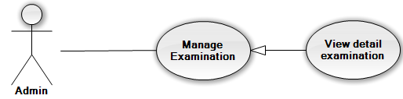

|  |  |  |  |  |
| --- | --- | --- | --- | --- |
| **USE CASE-UC014 SPECIFICATION** | | | | |
| **Use-case No.** | UC014 | **Use-case Version** | | 1.0 |
| **Use-case Name** | View detail examination | | | |
| **Author** | Trần Nguyễn Kim Vinh | | | |
| **Date** | 13/2/2014 | **Priority** | Normal | |
| **Actor:** Volunteer  **Summary:**  This use case allows admin can view detail of selected examination.  **Goal:** View detail of selected examination.  **Triggers:**  In manage examination page of admin, user click “[Chi tiết lịch thi](http://localhost:1045/Admin/ManageScheduleExam/1)”.  **Preconditions:**   * The user is already logged in with an account in admin role. * The manage examination is being display.   **Post Conditions:**  *On success:* Show detail of selected examination with start time and end time of each examination day.  *On failure:* An error message is displayed. The content of the error message will be specified in the Exception Scenario section based on the type of failure.  **Main Success Scenario:**   |  |  |  | | --- | --- | --- | | **Step** | **User Action** | **System Response** | | 1. | Click button “[Chi tiết lịch thi](http://localhost:1045/Admin/ManageScheduleExam/1)” delete on the row that contains the examination to be view detail |  | | 2. |  | Display a table content includes columns:   * Ngày thi * Giờ bắt đầu * Giờ kết thúc   Action: edit “Sửa” |   **Alternative Scenario: N/A**  **Exceptions: N/A**  **Relationships:** Mange examination  **Business Rules:** Admin also view detail of examination and edit time of examination. | | | | |

#### (Admin) Manage Examination – Delete Examination

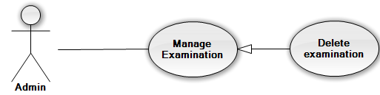

|  |  |  |  |  |
| --- | --- | --- | --- | --- |
| **USE CASE-UC015 SPECIFICATION** | | | | |
| **Use-case No.** | UC015 | **Use-case Version** | | 1.0 |
| **Use-case Name** | Delete examination | | | |
| **Author** | Trần Nguyễn Kim Vinh | | | |
| **Date** | 13/2/2014 | **Priority** | Low | |
| **Actor:** Admin  **Summary:**  This use case allows admin can delete a selected examination.  **Goal:** Deleted selected examination from database.  **Triggers:**  In manage post page of admin, user click button delete at examination user want delete.  **Preconditions:**   * The user is already logged in with an account in admin role. * The manage examination is being display. * The selected examination never used in any university examination   **Post Conditions:**  *On success:* Examination is deleted from database.  *On failure:* An error message is displayed. The content of the error message will be specified in the Exception Scenario section based on the type of failure.  **Main Success Scenario:**   |  |  |  | | --- | --- | --- | | **Step** | **User Action** | **System Response** | | 1. | Click button delete on the row that contains the examination to be deleted. |  | | 2. |  | Shows a popup to ask the user to confirm the action. | | 3. | Click “Xác nhận” to continue to delete the examination. |  | | 4. |  | Marks the selected examination as deleted in the database and redirect to manage examination page. |   **Alternative Scenario:**   |  |  |  |  | | --- | --- | --- | --- | | **No** | **Step** | **User Action** | **System Response** | | 1. | 1. | Clicks on the button “Hủy bỏ”. |  | | 2. |  | Hides the popup message. |   **Exceptions: N/A**  **Relationships:** Manage examination  **Business Rules**: If an examination have used in a university examination, user cannot delete that examination | | | | |

#### (Admin) Manage University Examination – Add new university examination

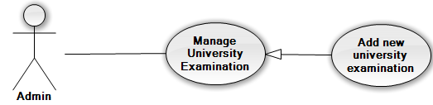

|  |  |  |  |  |
| --- | --- | --- | --- | --- |
| **USE CASE-UC016 SPECIFICATION** | | | | |
| **Use-case No.** | UC016 | **Use-case Version** | | 1.0 |
| **Use-case Name** | Add new university examination | | | |
| **Author** | Trần Nguyễn Kim Vinh | | | |
| **Date** | 13/2/2014 | **Priority** | Normal | |
| **Actor:** Admin  **Summary:**  This use case allows admin can create new university examination.  **Goal:** Create new university examination in database.  **Triggers:**  In manage university examination page of admin, user click “Tạo mới”.  **Preconditions:**   * The user is already logged in with an account in admin role. * The manage university examination is being display. * Have one or more universities and examinations in database.   **Post Conditions:**  *On success:* A new university examination is added into database.  *On failure:* An error message is displayed. The content of the error message will be specified in the Exception Scenario section based on the type of failure.  **Main Success Scenario:**   |  |  |  | | --- | --- | --- | | **Step** | **User Action** | **System Response** | | 1. | Click button “Tạo mới” in dashboard of manage university examination page. |  | | 2. |  | Displays a form that has the following items:   * “Trường” (combo box; required) * “Kỳ thi” (combo box; required) | | 3. | Choose one university and one examination. |  | | 4. | Clicks the button “Tạo”. |  | | 5. |  | Saves the new university examination into the database, redirects the user to the manage university examination page. |   **Alternative Scenario: N/A**  **Exceptions:**   |  |  |  | | --- | --- | --- | | **No** | **User Action** | **System Response** | | 1. | Choose university and examination have the same information with existing university examination in database.  Click “Tạo” | Show popup message “Trường này đã có đợt thi này, vui lòng chọn đợt thi khác”. |   **Relationships:**  Manage examination  **Business Rules:** Cannot add new examination have start date and end date as same as the examination exist in database | | | | |

#### (Admin) Approve post

|  |  |  |  |  |
| --- | --- | --- | --- | --- |
| **USE CASE-UC017 SPECIFICATION** | | | | |
| **Use-case No.** | UC017 | **Use-case Version** | | 1.0 |
| **Use-case Name** | Approve post | | | |
| **Author** | Trần Nguyễn Kim Vinh | | | |
| **Date** | 13/2/2014 | **Priority** | Normal | |
| **Actor:**  Admin  **Summary:**  This use case allows admin can approve a post.  **Goal:** Edit post.  **Triggers:**  In detail page of post, user click “Duyệt”.  **Preconditions:** The user is already logged in with an account in admin role.  Post added into database and status is not approve.  **Post Conditions:**  *On success:* Post is approved and display in “Tin tức” page.  *On failure:* An error message is displayed. The content of the error message will be specified in the Exception Scenario section based on the type of failure.  **Main Success Scenario:**   |  |  |  | | --- | --- | --- | | **Step** | **User Action** | **System Response** | | 1. | Click button “Duyệt” at detail page of the post will be approve. |  | | 2. |  | Shows a popup to ask the user to confirm the action. | | 3. | Click “OK” to continue to approve the post. |  | | 4. |  | Set status of this post as approved and redirect to manage post page. Post will display on “Tin tức” page. |   **Alternative Scenario:**   |  |  |  |  | | --- | --- | --- | --- | | **No** | **Step** | **User Action** | **System Response** | | 1. | 1. | Clicks on the button “Hủy bỏ”. |  | | 2. |  | Hides the popup message. |   **Exceptions: N/A**  **Relationships:** Manage post.  **Business Rules:** Only admin can approve a post. | | | | |

#### (Charity) Manage Charity Exam

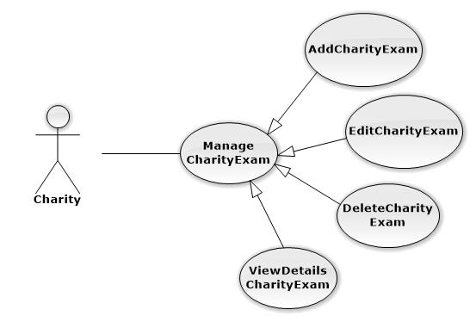

#### (Charity) Manage Charity Exam – Add charity exam

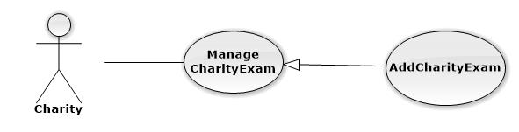

|  |  |  |  |  |
| --- | --- | --- | --- | --- |
| **USE CASE-UC018 SPECIFICATION** | | | | |
| **Use-case No.** | UC018 | **Use-case Version** | | 1.0 |
| **Use-case Name** | AddCharityExam | | | |
| **Author** | Nguyễn Vinh Hiển | | | |
| **Date** | 21/2/2014 | **Priority** | High | |
| **Actor:** Charity  **Summary:** This use case is about how Charity add charity exam  **Goal:** Add charity exam successful that volunteer, candidate and sponsor can interaction to.  **Triggers:** Charity click “Tạo” button to create new charity exam  **Preconditions:** User login into charity’s role  **Post Conditions:**  *On success:* New Charity Exam is displayed on charity exam’s table successfully  *On failure:* The error message is displayed  **Main Success Scenario:**   |  |  |  | | --- | --- | --- | |  | **User Action** | **System Response** | | 1. | User choose examination at “Kì thi” dropdownlist |  | | 2. |  | The examination that was chosen by the user at step 1 is displayed | | 3. | User click “Tạo” button |  | | 4. |  | _ The charity exam is added successful in the system  _ “Quản lí kì thi” page is displayed successfully with new charity exam in the table |   **Alternative Scenario:** N/A  **Exceptions:** When charity choose the examination that already have charity exam, the system will notify and require chosen again  **Relationships: N/A** | | | | |

#### (Charity) Manage Charity Exam – Edit Charity Exam

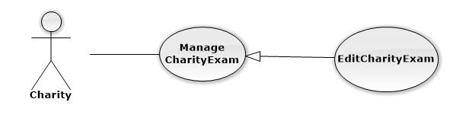

|  |  |  |  |  |
| --- | --- | --- | --- | --- |
| **USE CASE-UC019 SPECIFICATION** | | | | |
| **Use-case No.** | UC019 | **Use-case Version** | | 1.0 |
| **Use-case Name** | EditCharityExam | | | |
| **Author** | Nguyễn Vinh Hiển | | | |
| **Date** | 21/2/2014 | **Priority** | Normal | |
| **Actor:** Charity  **Summary:** This use case is about how Charity add charity exam  **Goal:** Add charity exam successful that volunteer, candidate and sponsor can interaction to.  **Triggers:** Charity click “Tạo kì thi” button on “Quản lí kì thi” page.  **Preconditions:** User login into charity’s role  **Post Conditions:**  *On success:* New Charity Exam is displayed on charity exam’s table successfully  *On failure:* The error message is displayed  **Main Success Scenario:**   |  |  |  | | --- | --- | --- | |  | **User Action** | **System Response** | | 1. | User choose examination at “Kì thi” dropdownlist |  | | 2. |  | The examination that was chosen by the user at step 1 is displayed | | 3. | User click “Sửa” button |  | | 4. |  | _ The charity exam is edited successful in the system  _ “Quản lí kì thi” page is displayed successfully with edited charity exam in the table |   **Alternative Scenario:** N/A  **Exceptions:** When charity choose the examination that already have charity exam, the system will notify and require chosen again  **Relationships: N/A** | | | | |

#### (Charity) Manage Charity Exam – Delete Charity Exam

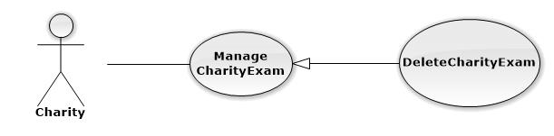

|  |  |  |  |  |
| --- | --- | --- | --- | --- |
| **USE CASE-UC020 SPECIFICATION** | | | | |
| **Use-case No.** | UC020 | **Use-case Version** | | 1.0 |
| **Use-case Name** | DeleteCharityExam | | | |
| **Author** | Nguyễn Vinh Hiển | | | |
| **Date** | 21/2/2014 | **Priority** | Normal | |
| **Actor:** Charity  **Summary:** This use case is about how Charity delete the charity exam  **Goal:** Delete the charity exam successfully  **Triggers:** Charity click “Xóa” icon at the same row of the CE.  **Preconditions: _**User login into charity’s role  _ The Charity exam that charity want to delete mustn’t used before  **Post Conditions:**  *On success:* The CE is delete successfully and fade out the table  *On failure:* N/A  **Main Success Scenario:**   |  |  |  | | --- | --- | --- | |  | **User Action** | **System Response** | | 1. | User click “Xóa” icon at the same row of the CE |  | | 2. |  | System display popup to confirm | | 3. | User click “Xác nhận” to delete |  | | 4. |  | The CE is faded out of the table and no longer exist at the system |   **Alternative Scenario:** N/A  **Exceptions:** N/A  **Relationships: N/A** | | | | |

#### (Charity) Manage Car Charity

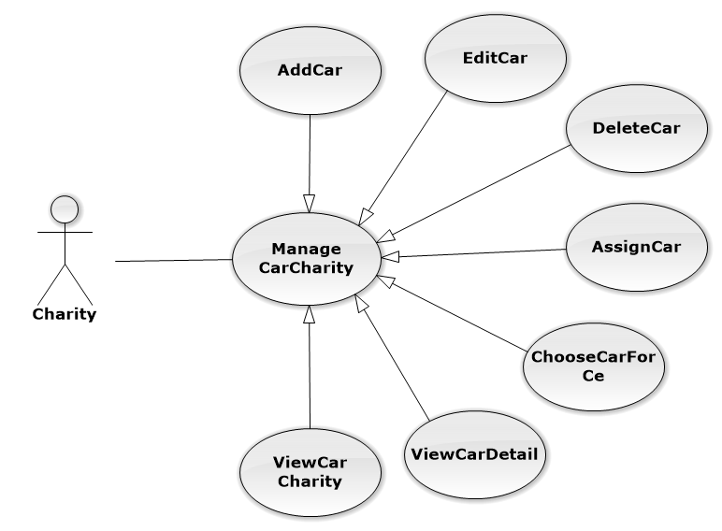

#### (Charity) Manage Car Charity – Add car

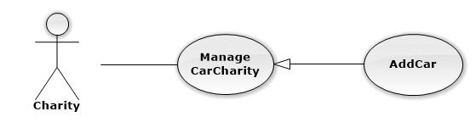

|  |  |  |  |  |
| --- | --- | --- | --- | --- |
| **USE CASE-UC021 SPECIFICATION** | | | | |
| **Use-case No.** | UC021 | **Use-case Version** | | 1.0 |
| **Use-case Name** | AddCar | | | |
| **Author** | Nguyễn Vinh Hiển | | | |
| **Date** | 21/2/2014 | **Priority** | High | |
| **Actor:** Charity  **Summary:** This use case is about how Charity add a new car  **Goal:** Add Car successful that charity can use to assign to charity exam  **Triggers:** Charity click “Tạo” button to create a new car.  **Preconditions:** User login into charity’s role  **Post Conditions:**  *On success:* New Car is displayed on charity’s car table successfully  *On failure:* The error message is displayed  **Main Success Scenario:**   |  |  |  | | --- | --- | --- | |  | **User Action** | **System Response** | | 1. | User fill information into textbox |  | | 2. |  | The information that user filled in step 1 is displayed exactly in textbox | | 3. | User click “Tạo” button |  | | 4. |  | _ The new car is added into the system successfully  _ “Quản lí xe của hội từ thiện” page is displayed successfully with new car in the table |   **Alternative Scenario:**   |  |  |  | | --- | --- | --- | |  | **User Action** | **System Response** | | 1. | User fill information into textbox |  | | 2. |  | The information that user filled in step 1 is displayed exactly in textbox | | 3. | User choose charity exam at “Kì thi” drop down list |  | | 4. | User click “Tạo” button |  | | 5. |  | _ The new car is added into the system successfully  _ “Quản lí xe của hội từ thiện” page is displayed successfully with new car in the table  _ The new car is assigned into charity exam successfully |   **Exceptions:**   |  |  |  | | --- | --- | --- | |  | **User Action** | **System Response** | | 1. | User fill character into “Số chỗ” textbox |  | | 2. |  | The error message is displayed | | 3. | User doesn’t fill into “Biển số xe” textbox |  | | 4. |  | The error message is displayed |   **Relationships: N/A** | | | | |

#### (Charity) Manage Car Charity – Edit car

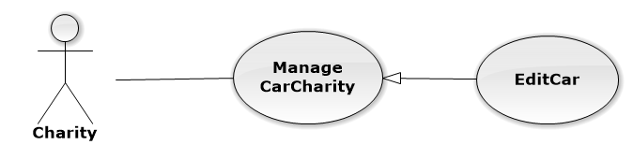

|  |  |  |  |  |
| --- | --- | --- | --- | --- |
| **USE CASE-UC022 SPECIFICATION** | | | | |
| **Use-case No.** | UC022 | **Use-case Version** | | 1.0 |
| **Use-case Name** | EditCar | | | |
| **Author** | Nguyễn Vinh Hiển | | | |
| **Date** | 21/2/2014 | **Priority** | Normal | |
| **Actor:** Charity  **Summary:** This use case is about how Charity edit a car  **Goal:** Edit car’s detail successfully  **Triggers:** Charity click “Sửa” button to edit a car.  **Preconditions:** User login into charity’s role  **Post Conditions:**  *On success:* The car with new detail is displayed on charity’s car table successfully  *On failure:* The error message is displayed  **Main Success Scenario:**   |  |  |  | | --- | --- | --- | |  | **User Action** | **System Response** | | 1. | User fill information into textbox |  | | 2. |  | The information that user filled in step 1 is displayed exactly in textbox | | 3. | User click “Suwar” button |  | | 4. |  | _ The car is edited successfully  _ “Quản lí xe của hội từ thiện” page is displayed successfully with a car in the table |   **Alternative Scenario:**   |  |  |  | | --- | --- | --- | |  | **User Action** | **System Response** | | 1. | User fill information into textbox |  | | 2. |  | The information that user filled in step 1 is displayed exactly in textbox | | 3. | User choose charity exam at “Kì thi” drop down list |  | | 4. | User click “Sửa” button |  | | 5. |  | _ The car is edited into the system successfully  _ “Quản lí xe của hội từ thiện” page is displayed successfully with new car in the table  _ The car is assigned into charity exam successfully |   **Exceptions:**   |  |  |  | | --- | --- | --- | |  | **User Action** | **System Response** | | 1. | User fill character into “Số chỗ” textbox |  | | 2. |  | The error message is displayed | | 3. | User doesn’t fill into “Biển số xe” textbox |  | | 4. |  | The error message is displayed |   **Relationships: N/A** | | | | |

#### (Charity) Manage Car Charity – Assign Car

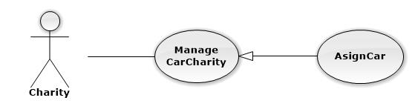

|  |  |  |  |  |
| --- | --- | --- | --- | --- |
| **USE CASE-UC023 SPECIFICATION** | | | | |
| **Use-case No.** | UC023 | **Use-case Version** | | 1.0 |
| **Use-case Name** | AssignCar | | | |
| **Author** | Nguyễn Vinh Hiển | | | |
| **Date** | 21/2/2014 | **Priority** | Normal | |
| **Actor:** Charity  **Summary:** This use case is about how Charity assign a car  **Goal:** Assign car to charity exam successfully  **Triggers:** Charity click “Chọn” button to assign a car to charity exam  **Preconditions:** User login into charity’s role  **Post Conditions:**  *On success:* The car is assigned to the charity exam successfully, this charity can use a car for candidate  *On failure:* The error message is displayed  **Main Success Scenario:**   |  |  |  | | --- | --- | --- | |  | **User Action** | **System Response** | | 1. | User choose charity exam at “Kì thi” drop down list |  | | 2. |  | The charity exam that user chose in step 1 is displayed exactly in textbox | | 3. | User click “chọn” button |  | | 4. |  | _ The car is assigned successfully  _ “Quản lí xe của hội từ thiện” page is displayed successfully with a car were assigned |   **Alternative Scenario: N/A**  **Exceptions: N/A**  **Relationships: N/A** | | | | |

#### (Charity) Manage Car Charity – Choose Car For Charity Exam

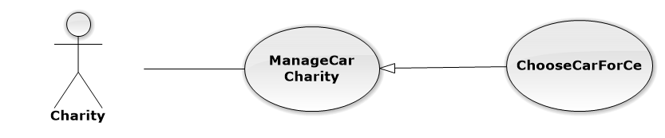

|  |  |  |  |  |
| --- | --- | --- | --- | --- |
| **USE CASE-UC024 SPECIFICATION** | | | | |
| **Use-case No.** | UC024 | **Use-case Version** | | 1.0 |
| **Use-case Name** | ChooseCarForCe | | | |
| **Author** | Nguyễn Vinh Hiển | | | |
| **Date** | 21/2/2014 | **Priority** | Normal | |
| **Actor:** Charity  **Summary:** This use case is about how Charity assign a cars to charity exam  **Goal:** Assign cars to charity exam successfully  **Triggers:** Charity click “Chọn” button to assign cars to charity exam  **Preconditions:** User login into charity’s role  **Post Conditions:**  *On success:* Cars is assigned to the charity exam successfully, this charity can use cars for candidate  *On failure:* The error message is displayed  **Main Success Scenario:**   |  |  |  | | --- | --- | --- | |  | **User Action** | **System Response** | | 1. | User choose cars by click on checkbox at the beginning of each car |  | | 2. | User click “chọn” button |  | | 3. |  | _ The cars is assigned successfully  _ “Quản lí xe của hội từ thiện” page is displayed successfully with cars were assigned |   **Alternative Scenario: N/A**  **Exceptions: N/A**  **Relationships: N/A** | | | | |

#### (Charity) Manage Car Charity – View Car Detail



|  |  |  |  |  |
| --- | --- | --- | --- | --- |
| **USE CASE-UC025 SPECIFICATION** | | | | |
| **Use-case No.** | UC025 | **Use-case Version** | | 1.0 |
| **Use-case Name** | ViewCarDetail | | | |
| **Author** | Nguyễn Vinh Hiển | | | |
| **Date** | 21/2/2014 | **Priority** | Normal | |
| **Actor:** Charity  **Summary:** This use case is about how Charity view detail of a car  **Goal:** View detail of a car successfully  **Triggers:** N/A  **Preconditions:** User login into charity’s role  **Post Conditions:**  *On success:* Car’s detail is displayed successfully with icon, number plate, slots, driver’s name , driver’s phone number.  *On failure:* The error message is displayed  **Main Success Scenario:**   |  |  |  | | --- | --- | --- | |  | **User Action** | **System Response** | | 1. | User click on “Xem chi tiết” icon of 1 car |  | | 2. |  | _ The detail of the car is displayed successfully  _ “Xem chi tiết xe “ is displayed successfully |   **Alternative Scenario: N/A**  **Exceptions: N/A**  **Relationships: N/A** | | | | |

#### (Charity) Manage Car Charity – View Car Of Charity



|  |  |  |  |  |
| --- | --- | --- | --- | --- |
| **USE CASE-UC026 SPECIFICATION** | | | | |
| **Use-case No.** | UC026 | **Use-case Version** | | 1.0 |
| **Use-case Name** | ViewCarCharity | | | |
| **Author** | Nguyễn Vinh Hiển | | | |
| **Date** | 21/2/2014 | **Priority** | Normal | |
| **Actor:** Charity  **Summary:** This use case is about how Charity view all of cars  **Goal:** View all of cars with detail successfully  **Triggers:** N/A  **Preconditions:** User login into charity’s role  **Post Conditions:**  *On success:* Cars and car’s detail is displayed successfully on table with number plate, charity exam, total slot, available slot  *On failure:* The error message is displayed  **Main Success Scenario:**   |  |  |  | | --- | --- | --- | |  | **User Action** | **System Response** | | 1. | User click on “Quản lý xe của tổ chức” icon |  | | 2. |  | _ The cars and the detail of the car is displayed successfully on table |   **Alternative Scenario: N/A**  **Exceptions: N/A**  **Relationships: N/A** | | | | |

#### (Charity) Manage Car Charity – Delete Car

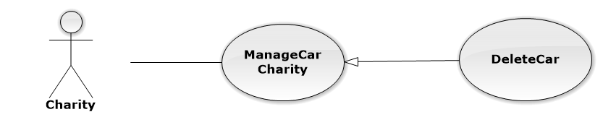

|  |  |  |  |  |
| --- | --- | --- | --- | --- |
| **USE CASE-UC027 SPECIFICATION** | | | | |
| **Use-case No.** | UC027 | **Use-case Version** | | 1.0 |
| **Use-case Name** | DeleteCar | | | |
| **Author** | Nguyễn Vinh Hiển | | | |
| **Date** | 21/2/2014 | **Priority** | Normal | |
| **Actor:** Charity  **Summary:** This use case is about how Charity delete the car  **Goal:** Delete the car successfully  **Triggers:** Charity click “Xóa” icon at the same row of the car.  **Preconditions: _**User login into charity’s role  _ The car that charity want to delete mustn’t used before  **Post Conditions:**  *On success:* The car is delete successfully and fade out the table  *On failure:* N/A  **Main Success Scenario:**   |  |  |  | | --- | --- | --- | |  | **User Action** | **System Response** | | 1. | User click “Xóa” icon at the same row of the car |  | | 2. |  | System display popup to confirm | | 3. | User click “Xác nhận” to delete |  | | 4. |  | The car is faded out of the table and no longer exist at the system |   **Alternative Scenario:** N/A  **Exceptions:** N/A  **Relationships: N/A** | | | | |

#### (Charity) Manage Lodge Charity

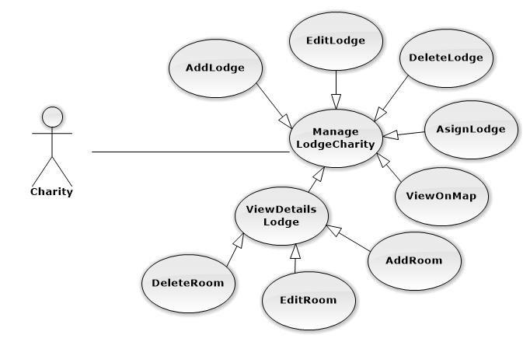

#### (Charity) Manage Lodge Charity – Add lodge

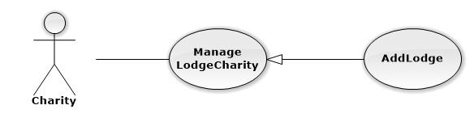

|  |  |  |  |  |
| --- | --- | --- | --- | --- |
| **USE CASE-UC028 SPECIFICATION** | | | | |
| **Use-case No.** | UC028 | **Use-case Version** | | 1.0 |
| **Use-case Name** | AddLodge | | | |
| **Author** | Nguyễn Vinh Hiển | | | |
| **Date** | 21/2/2014 | **Priority** | High | |
| **Actor:** Charity  **Summary:** This use case is about how Charity add a new lodge  **Goal:** Add lodge successful that charity can use to assign to charity exam  **Triggers:** Charity click “Tạo” button to create a new lodge.  **Preconditions:** User login into charity’s role  **Post Conditions:**  *On success:* New lodge is displayed on charity’s lodge table successfully  *On failure:* The error message is displayed  **Main Success Scenario:**   |  |  |  | | --- | --- | --- | |  | **User Action** | **System Response** | | 1. | User fill address into textbox |  | | 2. |  | The suggest address is displayed | | 3. | User choose the address of suggest address and click “Tạo” button |  | | 4. |  | _ The new lodge is added into the system successfully  _ “Quản lí nhà của hội từ thiện” page is displayed successfully with new lodge in the table |   **Alternative Scenario:**   |  |  |  | | --- | --- | --- | |  | **User Action** | **System Response** | | 1. | User drab place icon into the place of lodge |  | | 2. |  | The suggest address is displayed | | 3. | User choose the address of suggest address and click “Tạo” button |  | | 4. |  | _ The new lodge is added into the system successfully  _ “Quản lí nhà của hội từ thiện” page is displayed successfully with new lodge in the table |   **Exceptions:**   |  |  |  | | --- | --- | --- | |  | **User Action** | **System Response** | | 1. | User not fill address into “Địa chỉ” textbox |  | | 2. |  | The error message is displayed |   **Relationships: N/A** | | | | |

#### (Charity) Manage Lodge Charity – Edit Lodge

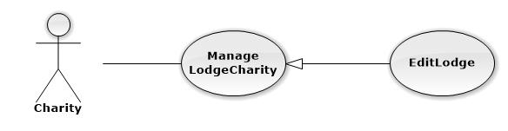

|  |  |  |  |  |
| --- | --- | --- | --- | --- |
| **USE CASE-UC029 SPECIFICATION** | | | | |
| **Use-case No.** | UC029 | **Use-case Version** | | 1.0 |
| **Use-case Name** | EditLodge | | | |
| **Author** | Nguyễn Vinh Hiển | | | |
| **Date** | 21/2/2014 | **Priority** | High | |
| **Actor:** Charity  **Summary:** This use case is about how Charity edit an exist lodge  **Goal:** Edit lodge successful that charity can use to assign to charity exam  **Triggers:** Charity click “Sửa” button to edit lodge.  **Preconditions:** User login into charity’s role  **Post Conditions:**  *On success:* The lodge is edited and displayed on charity’s lodge table successfully  *On failure:* The error message is displayed  **Main Success Scenario:**   |  |  |  | | --- | --- | --- | |  | **User Action** | **System Response** | | 1. | User fill address into textbox |  | | 2. |  | The suggest address is displayed | | 3. | User choose the address of suggest address and click “Sửa” button |  | | 4. |  | _ The lodge is edited into the system successfully  _ “Quản lí nhà của hội từ thiện” page is displayed successfully with edited lodge in the table |   **Alternative Scenario:**   |  |  |  | | --- | --- | --- | |  | **User Action** | **System Response** | | 1. | User drab place icon into the place of lodge |  | | 2. |  | The suggest address is displayed | | 3. | User choose the address of suggest address and click “Sửa” button |  | | 4. |  | _ The lodge is edited into the system successfully  _ “Quản lí nhà của hội từ thiện” page is displayed successfully with edited lodge in the table |   **Exceptions:**   |  |  |  | | --- | --- | --- | |  | **User Action** | **System Response** | | 1. | User not fill address into “Địa chỉ” textbox |  | | 2. |  | The error message is displayed |   **Relationships: N/A** | | | | |

#### (Charity) Manage Lodge Charity – Delete Lodge

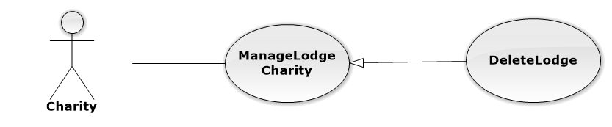

|  |  |  |  |  |
| --- | --- | --- | --- | --- |
| **USE CASE-UC030 SPECIFICATION** | | | | |
| **Use-case No.** | UC030 | **Use-case Version** | | 1.0 |
| **Use-case Name** | DeleteLodge | | | |
| **Author** | Nguyễn Vinh Hiển | | | |
| **Date** | 21/2/2014 | **Priority** | Normal | |
| **Actor:** Charity  **Summary:** This use case is about how Charity delete the lodge  **Goal:** Delete the lodge successfully  **Triggers:** Charity click “Xóa” icon at the same row of the lodge.  **Preconditions: _**User login into charity’s role  _ The lodge that charity want to delete mustn’t used before  **Post Conditions:**  *On success:* The lodge is delete successfully and fade out the table  *On failure:* N/A  **Main Success Scenario:**   |  |  |  | | --- | --- | --- | |  | **User Action** | **System Response** | | 1. | User click “Xóa” icon at the same row of the lodge |  | | 2. |  | System display popup to confirm | | 3. | User click “Xác nhận” to delete |  | | 4. |  | The lodge is faded out of the table and no longer exist at the system |   **Alternative Scenario:** N/A  **Exceptions:** N/A  **Relationships: N/A** | | | | |

#### (Charity) Manage Lodge Charity – Assign Lodge

#### Overall Use case diagram

#### Overall Use case diagram

#### Overall Use case diagram

#### Overall Use case diagram

#### Overall Use case diagram

## **Software System Attributes**

### Reliability

* Accurate: 99%

### Availability

* N/A

### Security

* Each role of user has a specific permission to interact with system
* TSMT system always checks authorization and authenticated before do anything

### Maintainability

* All the errors should be logged, supporting for bug fixing and maintenance

### Portability

* TMST should be accessible to anyone, with a personal computer that connects to the Internet and has a web browser

### Performance

* N/A

## **Entity Relationship Diagram**

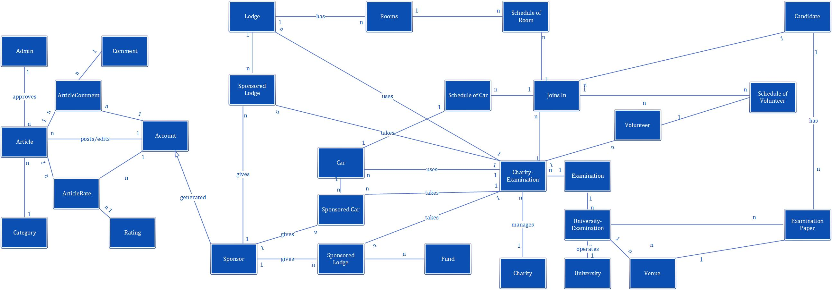

# **REPORT NO.4: SYSTEM DESIGN DESCRIPTION (SDD)**

## **Design Overview**

This part describes the detailed design of the TSMT website. It includes the system architectural design, component details and sequence diagrams. It also describes the graphical user interface and data structures of the system. This is to give the reader, a better understanding of the design process and procedure for this web application.

* The system architecture design describes the overview architecture of the system, the applied design pattern.
* Component diagram design describes the connection and integration of the system. It does not describe the functionality of the system but it describes the components used to make those functionalities.
* Detailed description of components describes static and dynamic structure for each component and function. It includes class diagrams and class diagram explanation.
* Sequence diagram describes the interactions between objects in the sequential order that those interactions occur. It depicts the objects and classes involved in the scenario and the messages exchanged between the objects needed to carry out the functionality of the scenario.
* User interface design demonstrates the layout of the system and graphical user interface in form of screen shots. It will also describe types of input, output element and the used action for each screen shot.

## **System Architectural Design**

MVC stands for model – view – controller pattern, was first introduced in the 1970s by Trygve Reenskaug. MVC is a software architecture pattern which separates the representation of information from user’s interaction with it. The model consists of application data, business rules, logic and functions. A view can be any output representation of data, such as a chart or a diagram. Multiple views of the same data are possible, such as bar chart for management and a tabular view for accountants. The controller mediates input, converting it to commands for the model or view. The central ideas behind MVC are code reusability and separation of concerns.

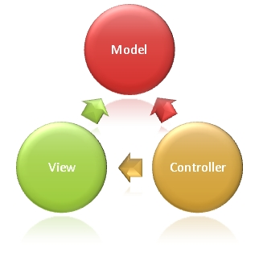

In addition to dividing the application into three kinds of components, the MVC design defines the interactions between them:

* A controller: can send commands to its associated view to changes the view’s presentation of model. It can also send commands to the model to update the model’s state
* A view: requests from the model information that it needs to generate an output representation to the user
* A model: notifies its associated views and controllers when there has been a change in its state. This notification allows the views to produce updated output, and the controllers to change the available set of commands.

## **Component Diagram**

## **Class diagram**

## **Behavioral Diagrams**

### **State Machine Diagram: The status transition of registering into a charity of candidate**

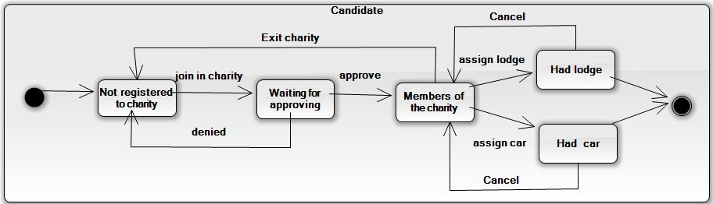

### **State Machine Diagram: The status transition of car being sponsored**

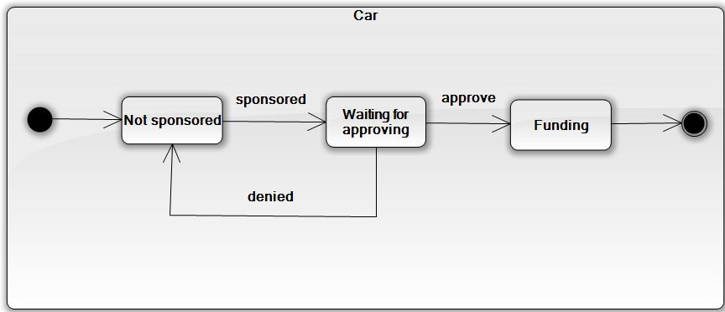

### **State Machine Diagram: The status transition of registering into charity of volunteer**

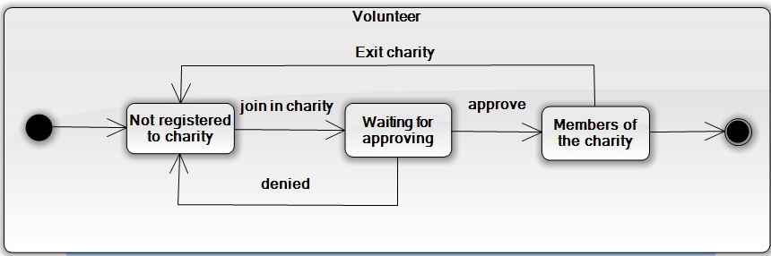

## **Database Design**

### **Logical Database Design**

### **Physical Database Design**

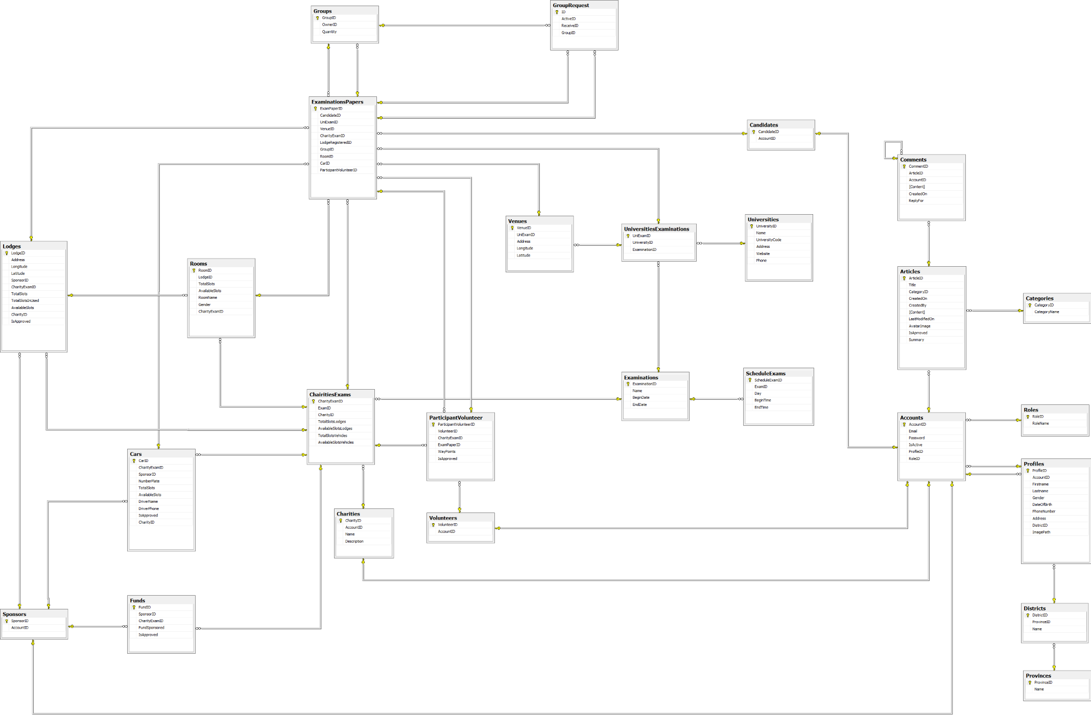

## **Algorithms**

**START**

NO

NO

YES

YES

YES

NO

Venues.Push(new Venue(Candidates.length - bestCar.FreeSlots ))

If bestCar.FreeSlots < Candidates.length

If bestCar != null

bestCar = FindMeTheBestCar()

If Candidates.length < 5

Candidates = candidates of CurrentVenue

CurrentVenue = Venues[0]

Order venues descending by number of candidates (in that lodge) join in

If Venues.length > 0

Venues = list of distinct venues of lodges

YES

YES

**END**

If Assign == fail

AssignCar(Candidates, bestCar)

AssignVolunteer

(Candidates)

NO

NO

Venues.Pop(0)

# **REPORT NO.5: SYSTEM IMPLEMENTATION & TEST (SIT)**

## **Introduction**

### **System Overview**

This section provides in detail all necessary information about test plans, test cases, test result, test environments, pass/fail/criteria and risks estimations as well as a checklist to cover all cases of TSMT

### **Test Approach**

* Goal: To find all remain bugs in TSMT system
* Method: Black box testing

## **Test Plan**

### **Feature to be tested**

### **Feature not to be tested**

## **Test Cases**

### **Admin Test Case**

#### Add an university

|  |  |  |  |  |  |  |  |
| --- | --- | --- | --- | --- | --- | --- | --- |
| Test case ID | Test Case Description | Test Case Procedure | Expected Output | Inter-Test Case Dependence | Result | Test Date | Note |
|  | **Pre-condition: 1.** Log in the system with Admin role  **2.** Click on the “Quản lý trường ĐH - CĐ” link in the menu bar  **3.** Click on “Tạo mới” button | | | | | | |
| [AU-1] | Try to add an university with incorrect input | * Make one or more validation errors when entering the information for the university. * Click the “Tạo” button. | The corresponding message will be shown next to the fields that have errorneous input. |  | Passed | 15/3/2014 |  |
| [AU-2] | Add an university with validated input | * Fill in all fields with validated input; * Click the “Tạo” button. | The university is saved into the database. The user is redirected to the Manage university page. |  | Passed | 15/3/2014 |  |

#### Add an university exam

|  |  |  |  |  |  |  |  |
| --- | --- | --- | --- | --- | --- | --- | --- |
| Test case ID | Test Case Description | Test Case Procedure | Expected Output | Inter-Test Case Dependence | Result | Test Date | Note |
|  | **Pre-condition: 1.** Log in the system with Admin role  **2.** Click on the “Đợt thi - trường ĐH-CĐ” link in the menu bar  **3.** Click on “Tạo mới” button  **4.** Have university and examination in database | | | | | | |
| [AUE-1] | Add an university exam with validated input | Add an university exam with validated input | Add an university exam with validated input |  | Pass | 15/3/2014 |  |
| [AUE-2] | Add an university exam with invalidated input | Add an university exam with invalidated input | Add an university exam with invalidated input |  | Pass | 15/3/2014 |  |

### **Volunteer Test Case**

#### Join and leave charity exam

|  |  |  |  |  |  |  |  |
| --- | --- | --- | --- | --- | --- | --- | --- |
| Test case ID | Test Case Description | Test Case Procedure | Expected Output | Inter-Test Case Dependence | Result | Test Date | Note |
|  | **Pre-condition: 1.** Log in the system with Volunteer role  **2**. User never register any charity exam  **3.** Click on the “Đăng ký” button | | | | | | |
| [JCE-1] | Volunteer join charity exam with validated input | * Click to choose exam * Click to choose charity exam * Click Term and condition * Click “Đăng ký” button | Registered to that charity exam and redirect to home page of volunteer with status register is “Chưa xác nhận”. |  | Pass | 15/3/2014 |  |
| [JCE-2] | Leave charity exam | User can leave charity exam when charity do not approve volunteer or volunteer not assign to carrying candidate   * Click “Hủy đăng ký” button | Remove request join charity exam and delete row contain register information. |  | Pass | 15/3/2014 |  |

### **Charity Test Case**

|  |  |  |  |  |  |  |  |
| --- | --- | --- | --- | --- | --- | --- | --- |
| Test case ID | Test Case Description | Test Case Procedure | Expected Output | Inter-Test Case Dependence | Result | Test Date | Note |
|  | **Pre-condition: 1.** Log in the system with Charity role | | | | | | |
| [CH-1] | Add a charity exam | * Click on the “Quản lý thông tin kỳ thi” link in the menu bar * Click on “Tạo mới” button * Click to choose examination; * Click the “Tạo” button. | The charity exam created and save into database, user redirect to Manage charity exam page. |  | Passed | 15/3/2014 |  |
| [CH-2] | Add a lodge | * Click on the “Quản lý chỗ trọ” link in the menu bar * Click on “Tạo mới” button * Enter address of lodge * Click “Đi đến” * Click the “Tạo” button. | The Lodge created and save into database, user redirect to Detail lodge page. |  | Passed | 15/3/2014 |  |
| [CH-3] | Add room for lodge | * At detail of lodge * Click “Tạo phòng” button * Enter all field * Click “Tạo mới” | The room created and save into database, user redirect to detail page. |  | Passed | 15/3/2014 |  |
| [CH-4] | View lodge on maps | * At Manage Lodge Charity page * Click button View map at the row of lodge user want to view | Open new window and show this lodge in Google maps. |  | Passed | 15/3/2014 |  |
| [CH-5] | Use lodge for charity exam | * At Manage Lodge Charity page * Click “Sử dụng” button * Click to choose examination * Click to choose room use for this examination * Click “Lưu” button | Rooms of lodge assigned to use in selected exam and save it into database. User redirected to Manage Lodge Charity page. |  | Passed | 15/3/2014 |  |
| [CH-6] | Add a car | * Click on the “Quản lý xe” link in the menu bar * Click on “Tạo mới” button * Enter all require fields * Click the “Tạo” button. | The car created and save into database, user redirect to Manage car charity page. |  | Passed | 15/3/2014 |  |
| [CH-7] | Use car for charity exam | * At Manage car charity page * Click “Sử dụng” button * Click to choose examination * Click to choose car use for this examination * Click “Lưu” button | Car assigned to use in selected exam and save it into database. User redirected to Manage car charity page. |  | Passed | 15/3/2014 |  |
| [CH-8] | Approve sponsor car that sponsored for charity exam | * Sponsor A sponsored a car for a charity exam * At Detail Charity Exam click “Quản lý xe” * Click “Xe được tài trợ” * Click Approve button | The car approved to use in charity exam and save it into database. Car’ status is “Đã duyệt”.  In Manage Car of Sponsor this car status is “Đã duyệt”. |  | Passed | 15/3/2014 |  |
| [CH-9] | Approve sponsor lodge that sponsored for charity exam | * Sponsor A sponsored a lodge for a charity exam * At Detail Charity Exam click “Quản lý chỗ trọ” * Click “Xe được tài trợ” * Click Approve button | The lodge approved to use in charity exam and save it into database.  In Manage Lodge of Sponsor this car status is “Đã duyệt”. |  | Passed | 15/3/2014 |  |

### **Candidate Test Case**

|  |  |  |  |  |  |  |  |
| --- | --- | --- | --- | --- | --- | --- | --- |
| Test case ID | Test Case Description | Test Case Procedure | Expected Output | Inter-Test Case Dependence | Result | Test Date | Note |
|  | **Pre-condition:** **1**. Log in the system with Candidate role | | | | | | |
| [CA-1] | Candidate join in Charity | * Click on the “Thông tin phiếu báo thi” link in the menu bar * Click on “Xem” button * Click on” Đăng ký ngay” button * Choose address of charity on google map and click “Đăng ký” | Candidate jon in charity was selected. And redirected to Manage Exam Paper page |  | Passed | 15/3/2014 |  |
| [CA-2] | Candidate use “ Tìm kiếm bạn bè” function | * Click on the “Thông tin phiếu báo thi” link in the menu bar * Click on “Xem” button * Click on” Tìm kiếm bạn bè button | Candidate see the all member of lodge with status “ Mời vào nhóm” |  | Passed | 15/3/2014 |  |
| [CA-3] | Candidate use “Mời vào nhóm” function | * Click on the “Thông tin phiếu báo thi” link in the menu bar * Click on “Xem” button * Click on”Tìm kiếm bạn bè” button * Click on “Mời vào nhóm” | Redirected to Find Friends page and status of member who was invited by candidate is “ Hủy lời mời” |  | Passed | 15/3/2014 |  |
| [CA-4] | Candidate use “Hủy lời mời” function | * Click on the “Thông tin phiếu báo thi” link in the menu bar * Click on “Xem” button * Click on”Tìm kiếm bạn bè” button * Click on “Hủy lời mời” | Redirected to Find Friends page and status of member who was invited by candidate is “ Mời vào nhóm” |  | Passed | 15/3/2014 |  |
| [CA-5] | Add new exam paper | * Click on the “Thông tin phiếu báo thi” link in the menu bar * Click on “Tạo mới” button * Select “kỳ thi”, “trường”, “Địa điểm thi” * Click on “Tạo mới” | The new exampaper created and save into database, user redirect to Manage Exampaper page. |  | Passed | 15/3/2014 |  |
| [CA-6] | Add new exam paper | * Click on the “Thông tin phiếu báo thi” link in the menu bar * Click on “Tạo mới” button * Do Not Select “Kỳ thi”, “Trường”, “Địa điểm thi”   Click on “Tạo mới” | * The corresponding message will be shown next to the fields Do Not Select “Kỳ thi”, “Trường”, “Địa điểm thi” |  | Passed | 15/3/2014 |  |

### **Sponsor Test Case**

#### Delete a car

|  |  |  |  |  |  |  |  |
| --- | --- | --- | --- | --- | --- | --- | --- |
| Test case ID | Test Case Description | Test Case Procedure | Expected Output | Inter-Test Case Dependence | Result | Test Date | Note |
|  | **Pre-condition: 1.** Log in the system with Sponsor role  **2.** Click on the “Quản lý xe” link in the menu bar  **3.** Click on “Xóa xe” icon | | | | | | |
| [DEC-1] | Delete a car | * Click OK when popup show up. | The car was removed from the database. The user is redirected to the Manage car page. |  | Passed | 15/3/2014 |  |
| [DEC-2] | Delete a car | * Click Cancel button when popup show up. | .Popup is close and user still in manage car page. |  | Passed | 15/3/2014 |  |

#### Sponsored Car

|  |  |  |  |  |  |  |  |
| --- | --- | --- | --- | --- | --- | --- | --- |
| Test case ID | Test Case Description | Test Case Procedure | Expected Output | Inter-Test Case Dependence | Result | Test Date | Note |
|  | **Pre-condition: 1.** Log in the system with Sponsor role  **2.** Click on the “Quản lý xe” link in the menu bar  **3.** Click on “Tài trợ xe” icon | | | | | | |
| [SPC-1] | Sponsored Car | * Click to choose an examination and charity to sponsored car * Click “Tài trợ” button | The car was sponsored for organization selected. The user is redirected to the Manage car page. |  | Passed | 15/3/2014 |  |
| [SPC-2] | Sponsored Car | * Not selected any organization * Click “Tài trợ” button | The corresponding message will be shown next to the fields Organization. |  | Passed | 15/3/2014 |  |

#### Cancel sponsored Car

|  |  |  |  |  |  |  |  |
| --- | --- | --- | --- | --- | --- | --- | --- |
| Test case ID | Test Case Description | Test Case Procedure | Expected Output | Inter-Test Case Dependence | Result | Test Date | Note |
|  | **Pre-condition: 1.** Log in the system with Sponsor role  **2.** Click on the “Quản lý xe” link in the menu bar  **3.** Click on “Hủy tài trợ” icon | | | | | | |
| [CSC-1] | Cancel sponsored Car | * Click OK when popup show up. | The car is no longer funding for any organization. The user is redirected to the Manage car page. |  | Passed | 15/3/2014 |  |
| [CSC-2] | Cancel sponsored Car | * Click Cancel button when popup show up. | Popup is close and user still in manage car page. |  | Passed | 15/3/2014 |  |

#### Sponsored many cars

|  |  |  |  |  |  |  |  |
| --- | --- | --- | --- | --- | --- | --- | --- |
| Test case ID | Test Case Description | Test Case Procedure | Expected Output | Inter-Test Case Dependence | Result | Test Date | Note |
|  | **Pre-condition: 1.** Log in the system with Sponsor role  **2.** Click on the “Quản lý xe” link in the menu bar  **3.** Click on “Tài trợ nhiều xe” icon | | | | | | |
|  | Sponsored Cars | * Click to choose a examination and charity to sponsored car * Do not selected any resource * Click “ Tài trợ” button | The cars were selected and sponsored for organization selected. . The user is redirected to the Manage car page. |  | Passed | 15/3/2014 |  |
|  | Sponsored Cars | * Click to choose a examination and charity to sponsored car * Do not check any checkbox for any cars. * Click “ Tài trợ” button | Popup is will show “ Vui lòng chọn xe để tài trợ” |  | Passed | 15/3/2014 |  |

#### Sponsored lodge and room of lodge

|  |  |  |  |  |  |  |  |
| --- | --- | --- | --- | --- | --- | --- | --- |
| Test case ID | Test Case Description | Test Case Procedure | Expected Output | Inter-Test Case Dependence | Result | Test Date | Note |
|  | **Pre-condition: 1.** Log in the system with Sponsor role  **2.** Click on the “Quản lý chỗ ở” link in the menu bar | | | | | | |
| [SLR-1] | Sponsored Lodge and room of lodge | * Click to choose a examination and charity to sponsored car * Do not check any checkbox for any cars. * Click “ Tài trợ” button | Popup is will show “ Vui lòng chọn phòng để tài trợ” |  | Pass | 07/04/2014 |  |
| [SLR-2] | Sponsored Lodge and room of lodge | * Do not click choose any examination and charity to sponsored car * . Click “ Tài trợ” button | The corresponding message will be shown next to the fields examination , charity. |  | Pass |  |  |

#### Sponsored Resource

|  |  |  |  |  |  |  |  |
| --- | --- | --- | --- | --- | --- | --- | --- |
| Test case ID | Test Case Description | Test Case Procedure | Expected Output | Inter-Test Case Dependence | Result | Test Date | Note |
|  | **Pre-condition: 1.** Log in the system with Sponsor role  **2.** Click on the “Ủng hộ tài nguyên” link in the menu bar | | | | | | |
| [SRE-1] | Sponsored Resource | * Click to choose a examination and charity to sponsored resource * Do not selecte any resource type. * Click “ Tài trợ” button | The corresponding message will be shown next to the fields Resource. |  | Passed | 15/3/2014 |  |
| [SRE-2] | Sponsored Resource | * Do not select examination and charity. * Click “ Tài trợ” button | The corresponding message will be shown next to the fields organization. |  | Passed | 15/3/2014 |  |
| [SRE-3] | Sponsored Resource | * Click to choose a university and examination to sponsored car * Choose type is car * Do not choose numberplate * Click “ Tài trợ” button | The corresponding message will be shown next to the fields numberpalte. |  | Passed | 15/3/2014 |  |
| [SRE-4] | Sponsored Resource | * Click to choose a university and examination to sponsored lodge * Choose type lodge * Do not choose address * Click “ Tài trợ” button | The corresponding message will be shown next to the fields address. |  | Passed | 15/3/2014 |  |
| [SRE-5] | Sponsored Resource | * Click to choose a university and examination to sponsored fund * Choose type is fund * Do not input fundSponsored * Click “ Tài trợ” button | The corresponding message will be shown next to the fields FundSponsored. |  | Passed | 15/3/2014 |  |
| [SRE-6] | Sponsored Resource | * Click to choose a university and examination to sponsored resource * Choose type of resource * Sponsored resource with validate input * Click “ Tài trợ” button | Sponsored resource for organization selected. . The user is redirected to the Manage with the resource page. |  | Passed | 15/3/2014 |  |

#### View statistic

|  |  |  |  |  |  |  |  |
| --- | --- | --- | --- | --- | --- | --- | --- |
| Test case ID | Test Case Description | Test Case Procedure | Expected Output | Inter-Test Case Dependence | Result | Test Date | Note |
|  | **Pre-condition: 1.** Log in the system with Sponsor role  **2.** Click on the “Xem thống kê” link in the menu bar | | | | | | |
| [VSS-1] | View statistic | * Do not select examination and charity. * Click “ Tài trợ” button | The corresponding message will be shown next to the fields organization. |  | Passed | 15/3/2014 |  |
| [VSS-2] | View statistic | * Select examination and charity. * Click “ Xem bản đồ” button | The chart show in the View Statistic page |  | Passed | 15/3/2014 |  |

# **REPORT NO.6: SYSTEM USER’S MANUAL (SUM)**

## **Installation Guide**

### **Server Side**

* Server must support ASP.NET 4.0, and Microsoft SQL Server 2008 R2
* Run file script TSMT.sql in SQL Server

### **Client Side**

* Work best with the Mozilla Firefox and Google Chrome browser

## **User’s Guide**

### **Minimum System Requirements**

* Personal computer for minimum configuration: 2 GB of RAM, 50 GB of hard disk, Core 2 Duo 2.0 GHz
* Microsoft Windows 7 or higher.
* At least 100MB for the application resources, and another 100MB for data storage.
* Internet connection
* Web server: IIS 7.0 or higher
* Database: SQL Server 2008 R2 or higher
* .NET Framework 4.5

### **Guide for guests and authorized users**

#### Search charity’s information

This function to allow user to search charity which registered to support in each exams

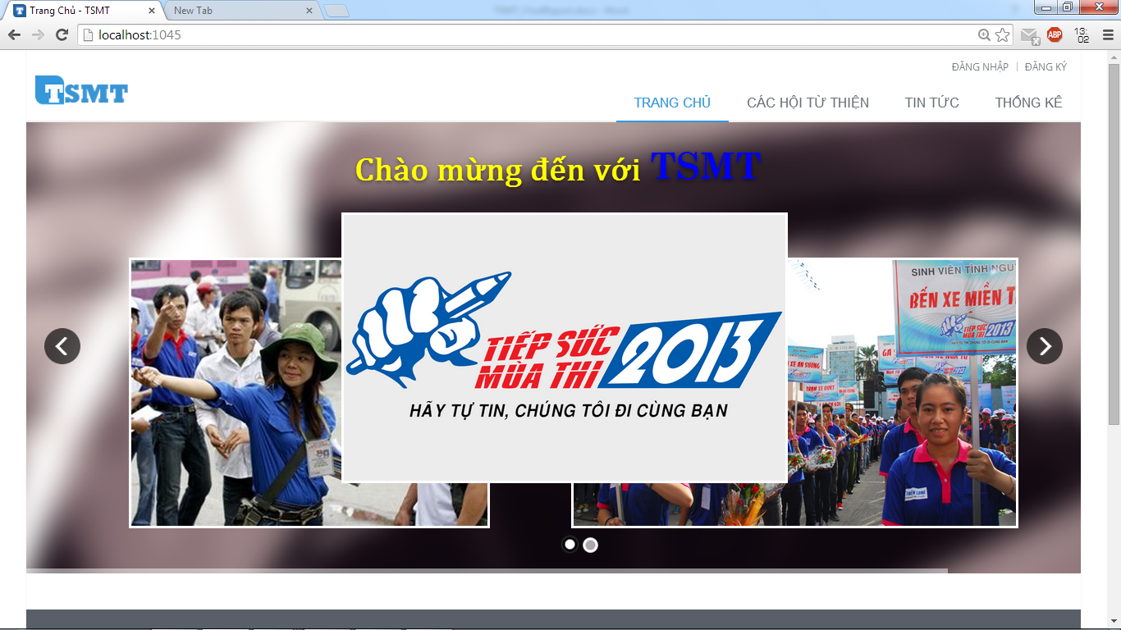

1

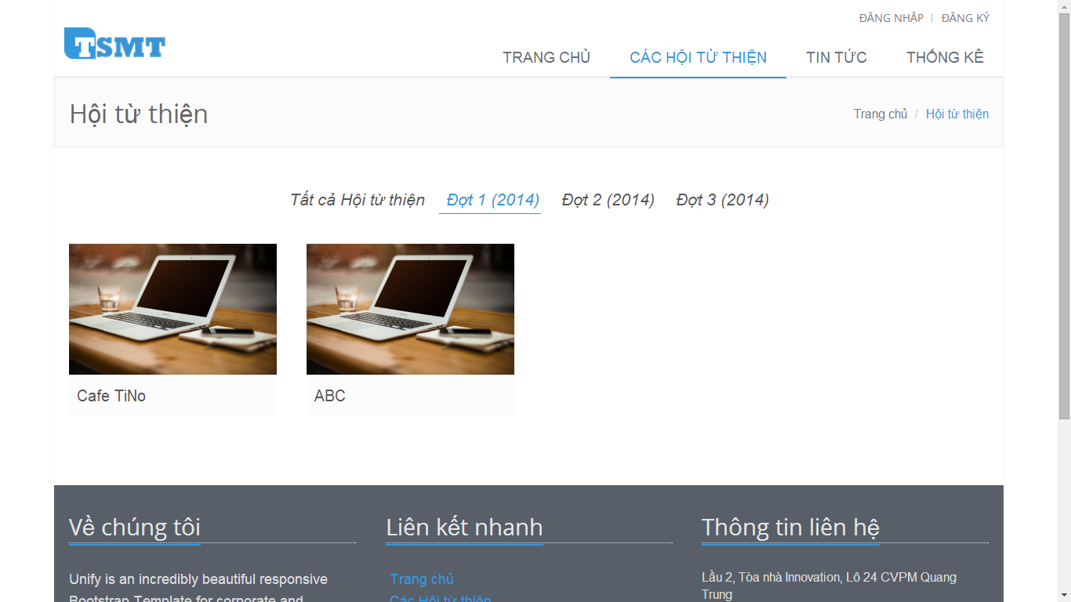

2

|  |  |
| --- | --- |
| Step | Instruction |
| 1 | Click “CÁC HỘI TỪ THIỆN” link on the main menu, you will be redirected to page to view all charities are register to support in each exams. |
| 2 | Click on   * “**Tất cả Hội từ thiện**” link, you will see all charities which registered to support in TSMT system * “**Đợt 1(2014)**”, “**Đợt 2(2014)**”, “**Đợt 3(2014)**” link, you can only view charities which registered to support in that examination. |

#### View information detail of charity

This function to help you view the detail information of charity. 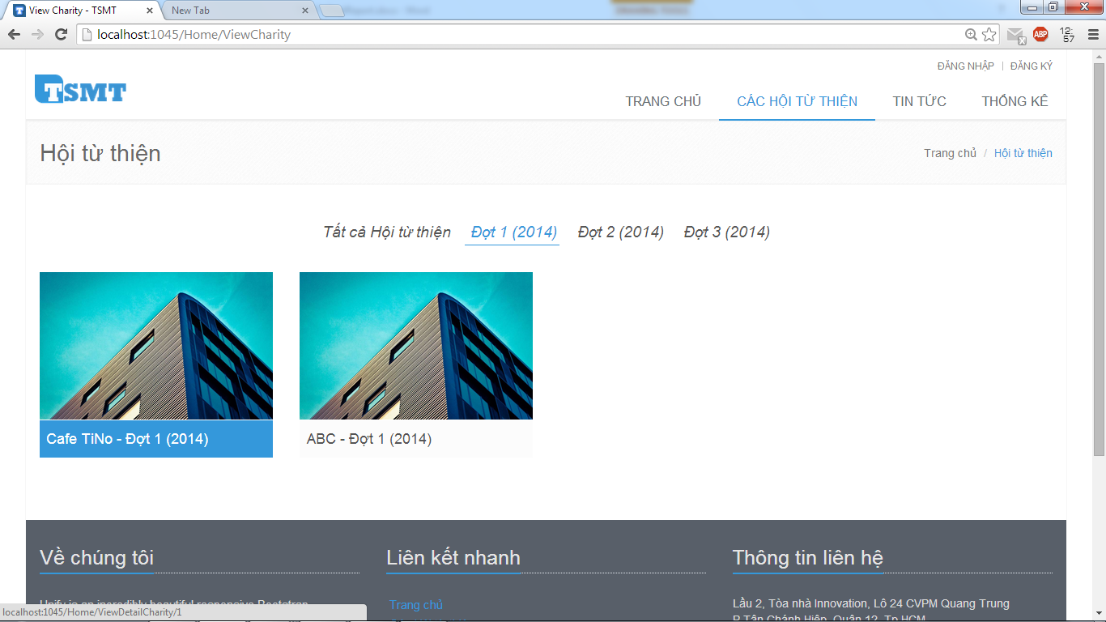

1

|  |  |
| --- | --- |
| Step | Instruction |
| 1 | When you move your mouse in one charity, that charity will be hover, then you click on it and you will be redirected to the page to view detail information of charity |

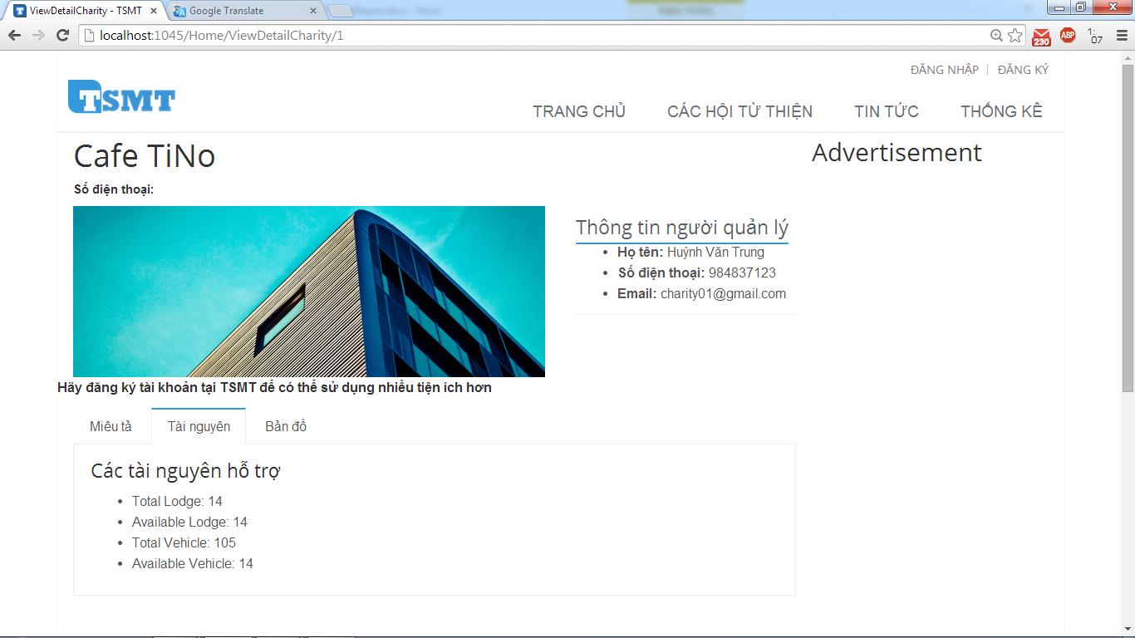

1

#### Register an account

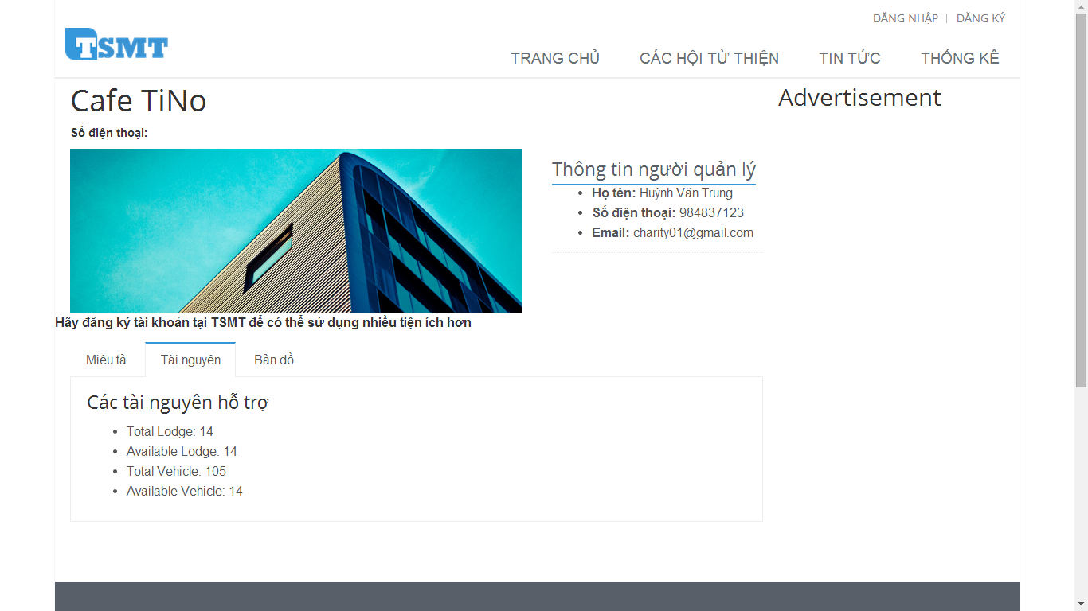

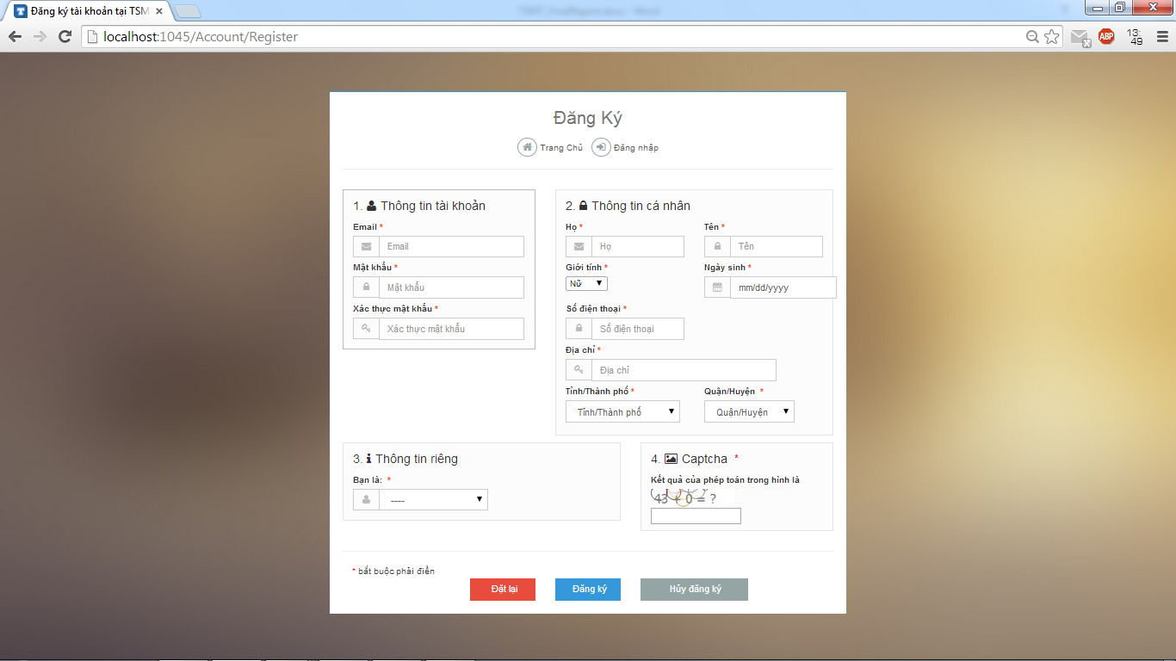

7

6

5

4

3

2

|  |  |
| --- | --- |
| Step | Instruction |
| 1 | Click on “Đăng ký” link, you will be redirected to the page to register an account in TSMT system |
| 2 | * Fill in the fields: “Email” with your email address, “Mật khẩu” with your password, “Xác thực mật khẩu” with your password which you filled on the “Mật khẩu” fields, “Họ” with your last name, middle name, “Tên” with your first name, “Số điện thoại” with your telephone number, “Địa chỉ” with your address * And choose value in combo box: “Giới tính”, “Ngày sinh”, “Tỉnh/Thành phố”, “Quận/Huyện”. * Then you choose the role which you want to register in TSTM system at combo box: “Bạn là:” * Finally, you fill the result of the captcha image with correct number. |
| 3 | Click the button “Đăng ký” to proceed to register your account.  If registered successfully, you will be directed to “Đăng nhập” page to login with the newly created account |
| 4 | [Optional] Click “Đặt lại” button to clear all fields and you must type again |
| 5 | [Optional] Click “Hủy đăng ký” button to cancel register and you will be redirected homepage |
| 6 | [Optional] Click “Trang chủ” link, you will be redirected the homepage |
| 7 | [Optional] Click “Đăng nhập” link, you will be redirected the log in page |

### **Guide for members**

#### Log in to the system



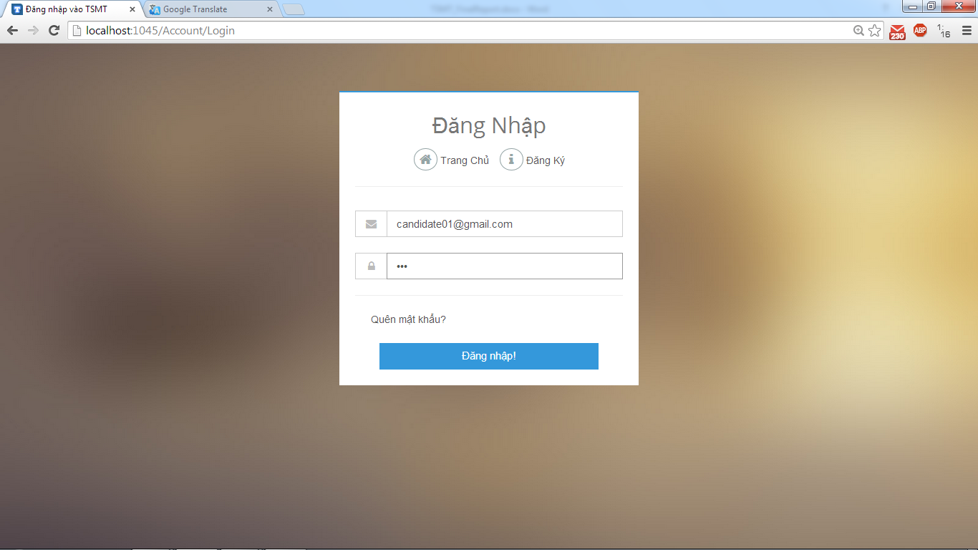

|  |  |
| --- | --- |
| Step | Instruction |
| 1 | When you move your move on |

#### Log out to the system

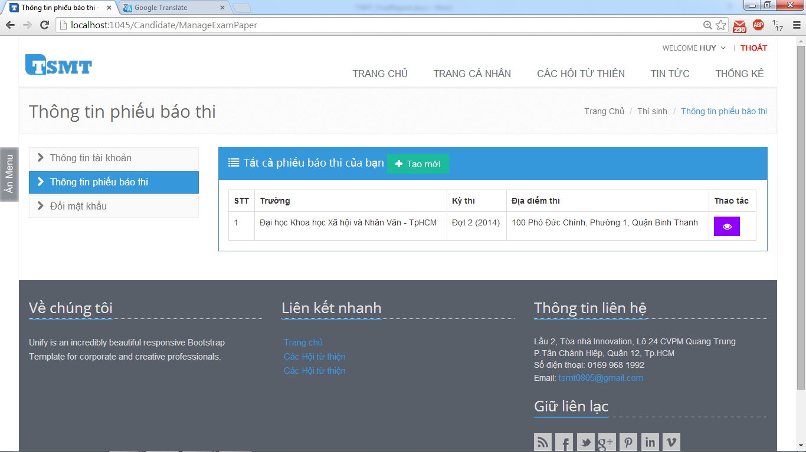

|  |  |
| --- | --- |
| Step | Instruction |
| 1 | When you move your move on |

### **Guide for candidates**

Register examination paper

Search lodges

Register into charities

View

### **Guide for sponsors**

### **Guide for charities**

### **Guide for admin**

# **APPENDIX**

References